SUBDIVISION AND DEVELOPMENT RULES AND REGULATIONS

YOUNG COUNTY, TEXAS

TABLE OF CONTENTS

ARTICLE 1. GENERAL PROVISIONS 4
Section 1.01 Short Title 4
Section 1.02 Authority 4
Section 1.03 Purpose 4
Section 1.04 Interpretation 4
Section 1.05 Definitions 4
Section 1.06 Severability and Validity 11
Section 1.07 Effective Date 11
Section 1.08 Compliance Required 11
Section 1.09 Penalty for Violation 11
Section 1.10 Variances 12
Section 1.11 Special Provisions for Enforcement 12
Section 1.12 Amendment 13
Section 1.13 Improvements Required 13
ARTICLE 2. GENERAL SUBDIVISION DEVELOPMENT PROCEDURE 14
Section 2.01 General 14
Section 2.02 Fee Schedule 14
Section 2.03 Procedure Summary 15
Section 2.04 Subdivision Development Procedure Chart 15
Section 2.05 Young County Contacts 15
Subdivision Development Procedure – A 17
Subdivision Development Procedure – B 18
Subdivision Development Procedure – C 19
ARTICLE 3. PRELIMINARY PLAT 20
Section 3.01 General 20
Section 3.02 Purpose 22
Section 3.03 Application 22
Section 3.04 Preliminary Plat Form and Content 22
Section 3.05 Property Information 23
Section 3.06 Roads 23
Section 3.07 Drainage 25
Section 3.08 Public and Private Utilities 26
Section 3.09 Developer’s Statement 27
Section 3.10 Processing of the Preliminary Plat 27
ARTICLE 4. FINAL PLAT & CONSTRUCTION DOCUMENTS 29
Section 4.01 General 29
Section 4.02 Replat 29
Section 4.03 Application 29
Section 4.04 Review Fee 30
Section 4.05 Final Plat Form and Content 30
Section 4.06 Supporting Documentation 34
Section 4.07 Construction Plans 36
Section 4.08 Method of Approval 38
Section 4.09 Filing of the Final Plat 40
ARTICLE 5. CONSTRUCTION 41
Section 5.01 General 41
Section 5.02 Inspection 41
Section 5.03 Storm Water Discharge Permit 44
Section 5.04 Final Inspection 44
Section 5.05 Record Drawings 44
Section 5.06 Maintenance Bond 44
Section 5.07 Acceptance by the County 45
ARTICLE 6. DESIGN CRITERIA 46
Section 6.01 General 46
Section 6.02 Lots 46
Section 6.03 Easements 47
Section 6.04 Storm Water Discharge Permit 48
Section 6.05 Alleys 49
Section 6.06 Roads 49
Section 6.07 Shared Access Driveways 53
Section 6.08 Drainage and Storm Sewer 54
Section 6.09 Public and Private Sewer Systems 60
Section 6.10 Water 61
Section 6.11 Fire Code 61
ARTICLE 7. MANUFACTURED HOME AND RECREATIONAL VEHICLE RENTAL COMMUNITIES 62
Section 7.01 General 62
Section 7.02 Fee Schedule 62
Section 7.03 Development Plan Requirements 62
Section 7.04 Development Plan Processing 62
ARTICLE 8. COMMERCIAL AND OTHER TYPES OF DEVELOPMENT 64
Section 8.01 General 64
Section 8.02 Fee Schedule 64
ARTICLE 9. CONSTRUCTION STANDARDS 65

APPENDIX
Threshold Analysis Worksheet Plat Package Checklists Subdivision Application Driveway Permit
Irrevocable Letter of Credit

ARTICLE 1. GENERAL PROVISIONS

Section 1.01 Short Title
This Court Order may be known and cited as the "Young County Subdivision Rules and Regulations."

Section 1.02 Authority
This Court Order is adopted under the authority of the Constitution and laws of the State of Texas, including particularly Chapter 232, Texas Local Government Code as heretofore or hereafter amended.

Section 1.03 Purpose
The purpose for which these Rules and Regulations are created is: to provide for the orderly, safe and healthful development of the area outside the limits of a municipality and within the County and to promote the health, safety and general welfare of the community; to establish orderly policies and procedures to guide development of the County; to provide for establishment of minimum specifications for construction and engineering design criteria to maintain land values, reduce inconveniences to residents of the area, and to reduce related unnecessary costs to the County for the correction of inadequate environmental conditions; to ensure that the development of land and subdivisions shall be of such nature, shape and location that utilization will not impair the general welfare and to ensure against the dangers of fires, floods, erosion, landslides, or other such menaces; to provide proper utilities and services for adequate drainage, water supply, and disposal of sanitary and industrial waste; to provide roads that ensure safe, convenient and functional systems for vehicular circulation.

Section 1.04 Interpretation

In the interpretation and application of the provisions of these regulations, it is the intention of the County Commissioners that the principles, standards and requirements provided for herein shall be minimum requirements for the platting and developing of subdivisions outside the limits of a municipality and within Young County, and, where other Court Orders of the County are more restrictive in their requirements, such other Court Orders shall control. For developments within the extraterritorial jurisdiction (ETJ) of a municipality, reference Section 3.01.B.

Section 1.05 Definitions
- For the purposes of this Court Order, certain terms or words herein shall be interpreted or defined as follows:

Words used in the present tense include the future tense; the singular includes the plural;
The word "person" includes a corporation as well as an individual; the term "shall" is always mandatory.
The term "may" is directory.

- Words and terms not expressly defined herein are to be construed according to the normally accepted meaning of such words or terms or, where no definition appears, then according to their customary usage in the practice of municipal planning and engineering.
  - 100-year Flood: See Base Flood.
  - Abandonment: The legal process by which land dedicated to public use may revert to private use.

  - Administrative Officers: Any office referred to in this Court Order by title, e.g., County Judge, County Commissioners, County Attorney, etc., shall be the person so retained in this position by the County, or their duly authorized representative.

  - Alley: A minor public right-of-way, not intended to provide the primary means of access to abutting lots, which is used primarily for vehicular service access to the back or sides of properties otherwise abutting on a street.
  - Amending Plat: A plat solely for the purpose of correcting an error, omission, descriptions, relocations of lot lines, scriveners or clerical errors. The amending plat must be approved by Commissioners Court, after which it may be recorded and is controlling over the preceding plat without vacation of that plat.

  - Area of Special Flood Hazard: The land in the flood plain within a community subject to a 1 percent or greater chance of flooding in a given year.

  - Base Flood: The flood having a one (1) percent chance of being equaled or exceeded in any given year, determined based upon FEMA (Federal Emergency Management Agency) guidelines and as shown in the current effective Flood Insurance Study. Also known as the 100-year flood.
  - Block: is a tract or parcel of land bounded by streets, or by a combination of streets and public parks, cemeteries, railroad rights-of-way, highway, stream, or corporate boundary lines.

  - Bridge Class Drainage Culverts: Culverts having an opening (i.e., distance) of more than 20 ft. [6.1 m] between the extreme inside faces as measured along the road centerline.

  - Building: is any structure built for support, shelter, or enclosure of persons, animals, or movable property of any kind.

  - Building Setback Line: The line within a property defining the minimum horizontal distance between a building or other structure and the adjacent street line.
  - Business Day: A day other than a Saturday, Sunday, or Holiday as recognized by
Young County.
  - Commercial or Institutional Facility: Any building that is not used as a single-family dwelling or duplex.
  - Commissioner's Court: The duly elected governing body of Young County, Texas.
  - Construction Plans: See Engineering Plans.
  - County: Young County, Texas, together with all its governing and operating bodies.

  - County Attorney: "County Attorney" shall apply only to such individual or firm qualified to represent clients in a court of law and to advise clients on legal matters and having been specifically designated by the Commissioner's Court.

  - County Commissioner: The officially elected, appointed or authorized County Commissioner of a particular district of Young County, Texas, or the County Commissioner's duly authorized representative.
  - County Road: A public road or street which has been either: a) dedicated to public use and accepted for maintenance by the County, or b) acquired by the County through prescription, or c) is a road or street that was constructed by and is maintained by the County.
  - Court: see Commissioner's Court.
  - Cul-de-sac: A street having but one outlet to another street, and terminated on the opposite end by a vehicular turnaround.
  - Dead-End Street: A street, other than a cul-de-sac, with only one outlet.
  - Developer: See sub-divider.
  - Double Frontage Lot: A lot which fronts onto one street and backs onto another street.
  - Easement: The word "easement" shall mean an area for restricted use on private property upon which any public utility shall have the right to remove and keep removed all or part of any buildings, fences, trees, shrubs, or other improvements or growths which in any way endanger or interfere with the construction, maintenance, or efficiency of its respective systems on any of these easements. Any public utility shall at all times have the right of ingress and egress upon the said easements for the purpose of constructing, reconstructing, inspecting, patrolling, maintaining and adding to or removing all or part of its respective systems without the necessity at any time of procuring the permission of anyone.
  - Engineer: A person duly authorized under the provisions of the Texas Engineering Practice Act, as heretofore or hereafter amended, to practice the profession of engineering and who is specifically qualified to design and prepare Construction Plans and specifications for subdivision development.
  - Engineering Plans: A set of drawings and/or specifications, including paving, water, wastewater, drainage, or other required plans, submitted to the County for review in conjunction with a subdivision or a development that bear the seal and signature of a Licensed Engineer in the State of Texas. This person shall be designated as the Engineer of Record.

  - Extraterritorial Jurisdiction: The unincorporated area of the County that is contiguous to the corporate boundaries of a municipality, more specifically described in Section 42.021 of the Local Government Code, as same may exist or be amended in the future.

  - Eyebrow: A widening of the roadway section to allow additional space for turning movements which is not located at a dead end. Eyebrows are typically located at a change in the roadway to provide additional lot access. An eyebrow allows for a turning radius equal to or greater than 60 feet.

- Final Acceptance: Acceptance by the Young County Commissioner's Court of all public infrastructure improvements constructed by the developer in conjunction with the development of land.

- Final Plat: (Also Record Plat or Filing Plat). The one official and authentic map of any given subdivision of land prepared from actual field measurement and staking of all identifiable points by a Surveyor with the subdivision location referenced to a survey corner and all boundaries, corners and curves of the land division sufficiently described so that they can be reproduced without additional references. Angular measurements and bearings shall be accurate to the nearest minute. Distances shall be accurate to the nearest tenth of a foot. The Final Plat of any lot, tract, or parcel of land shall be recorded in the Deed Records of Young County, Texas.
- Final Plat Package: Consists of a Final Plat, Construction Plans and a Drainage Plan plus all other supporting documentation as detailed in Article 4 – Final Plat & Construction Documents, that must be submitted to Young County Commissioner's Court for review.
- Flood Hazard Boundary Map (FHBM): An official map of a community issued by the Federal Insurance Administrator (FIA) where the boundaries of the flood, mudslide related erosion areas having special hazards have been designated as Zones A, M and/or E.
- FIA: Federal Insurance Administrator
- Flood Insurance Rate Map (FIRM): An official map of a community on which the FIA has delineated both the special hazard areas and the risk premium zones applicable to the community.

- Flood Insurance Study: An examination, evaluation and determination of the flood hazards and, if appropriate, corresponding water surface elevations, or an examination, evaluation and determination of mudslide and/or flood-related erosion hazards.

- Flood Plain: Any land area susceptible to being inundated by flood waters from any source, as defined by the Federal Emergency Management Agency (FEMA).
- Floodway: See Regulatory Floodway.
- Floodway Easement: A drainage area dedicated to the county for control and maintenance of a flood plain.

- Flowage Easement: A drainage area reserved for the flooding of a body of water, such as a lake or reservoir.

- Freeboard: The vertical distance between the designated water surface level and the top of an open conduit, or low chord elevation, left to allow for wave action, floating debris or any other condition or emergency without overtopping the structure.
- Homeowners (Property Owners) Association is a formal nonprofit organization operating under recorded land agreements through which (a) each lot and/or homeowner in a specific residential area is automatically a member and (b) each lot or property interest is automatically subject to a charge for a proportionate share of the expense for the organization's activities, such as the maintenance of common property, and (c) the charge if unpaid, becomes a lien against the nonpaying member's property.

- Infrastructure: All roads, alleys, storm drainage, water, and wastewater facilities, utilities, and other facilities as required by Young County.
- Installer: An individual who holds a valid certificate and is compensated by another to perform services, construct, install, alter, or repair an OSSF.

- Large Construction Activity: Construction activities including clearing, grading and excavating that result in land disturbance of equal to or greater than five (5) acres of land. Large construction activities also include the disturbance of less than five (5) acres of total land area that is part of a larger common development or sale if the larger common plan will ultimately disturb equal to or greater than five (5) acres of land. Large construction activity does not include routine maintenance that is performed to maintain the original line and grade, hydraulic capacity, and original purpose of a ditch, channel, or other similar storm water conveyance. Large construction activity does not include the routine grading of existing dirt roads, asphalt overlays of existing roads, the routine clearing of existing right-of-ways, and similar maintenance activities.
- Lines, Building: See Building Setback Lines
- Lot: An undivided tract or parcel of land having frontage on a public road and which is, or in the future may be offered for sale, conveyance, transfer or improvement; which is designated as a distinct and separate tract, and which is identified by a tract or lot number or symbol in a duly approved subdivision plat which has been properly filed of record.
- Manufactured Home: As defined by the United States Department of Housing and Urban Development, a structure: constructed on or after June 15, 1976; built on a permanent chassis; designed for use as a dwelling with or without a permanent foundation when the structure is connected to the required utilities; transportable in one or more sections; and in the traveling mode, at least eight (8) body feet in width or at least 40 body feet in length or, when erected on site, at least 320 square feet. The unit includes the plumbing, heating, air conditioning, and electrical systems of the home. The unit does not include a recreational vehicle as defined by these Rules and Regulations.
- Master Thoroughfare Plan: Official long range planning document that establishes a future roadway network system that will accommodate projected growth and development.

- Multi-Unit Residential Development: Any area developed or used for a structure or combination of structures designed to lease or rent space to house two or more families.

- Non-Residential Development: Any area developed for a use other than single-family or multi-unit residential.

- Notice of Intent (NOI): A written submission to the executive director from an applicant requesting coverage under a general permit.
- Off-site: Located outside the boundary of a development.
- On-site: Located within the boundary of a development.
- On-site Sewage Facility (OSSF): One or more systems of treatment devices and disposal facilities that produce not more than 5,000 gallons of waste each day; and are used only for disposal of sewage produced on the site where the system is located as permitted by Young County.
- Owner: See Subdivider
- Pavement Width: The portion of a road available for vehicular traffic. Where curbs are laid, it is the portion between the face of the curbs. Otherwise, it is the portion between the edges of pavement.
- Planner: Persons other than Professional Engineers or Registered Professional Land Surveyors who are proficient in the planning of residential, commercial, industrial and other related developments as demonstrated by membership in the American Institute of Certified Planners (AICP).

- Planning Materials: Plans, applications, site evaluations, and other supporting materials submitted to the permitting authority for the purpose of obtaining a permit in accordance with TCEQ Title 30 TAC Chapter 285.
- Plat: See Final Plat.
- Plat Amendment: See Amending Plat.
- Potable Water: All water distributed by any agency or individual, public or private, for the purpose of human consumption or which may be used in the preparation of foods or beverages or for the cleaning of any utensil or article used in the course of preparation or consumption of food or beverages for human beings. The term shall also include all water supplied for human consumption or used by any institution catering to the public.

- Precinct Commissioner: The County Commissioner in whose precinct a subdivision is being planned or built.
- Preliminary Plat: The graphic expression of the proposed overall plan for subdividing, improving and developing a tract shown by superimposing a scale drawing of the proposed land division on a topographic map and showing in plan existing and proposed drainage features and facilities, road layout and direction of curb flow, and other pertinent features with notations sufficient to substantially identify the general scope and detail of proposed development.

- Preliminary Plat Package: Consists of the Preliminary Plat, Preliminary Drainage Plan plus all other supporting documentation as described in Article 3 – Preliminary Plat, which must be submitted to Young County Commissioner's Court for review.
- Private Road: Any road that does not fall under the definition of a “County Road” above, and a) is not designated as a State Highway, or b) is not designated as an Interstate Highway.
- Private Sewage Facility: See On-Site Sewage Facility.
- Private Water Supply: A drinking water supply that is not a public source of drinking water.

- Professional Land Surveyor: A person duly authorized under the provisions and statutes of the Texas Surveyors Registration Act to practice the profession of surveying.

- Public Water Supply: A public water system which provides the public piped water for human consumption, which includes all uses described under the definition of drinking water. Such a system must have a potential for at least 15 service connections or serve at least 25 individuals at least 60 days out of the year, or in accordance with the most recent TCEQ guidelines.

- Recreational Vehicles: As defined by 24 C.F.R. Section 3282.8(g), a vehicle which is built on a single chassis; 400 square feet or less when measured at the largest horizontal projections; self-propelled or permanently towable by a light duty truck; and designed primarily not for use as a permanent dwelling but as temporary living quarters for recreational, camping, travel, or seasonal use.

- Regulatory Floodway: The channel of a river or other watercourse and the adjacent land areas that must be reserved in order to discharge the base flood without cumulatively increasing the water surface elevation more than one (1) foot

- Replat: Any change to an approved plat to reflect any change in any street layout or any other public improvement, lot line, amount of land reserved for public use or the common use of lot owners, or easements shown.

- Replatting: The resubdivision of any part or all of any block or blocks of a previously platted subdivision, addition, lot or tract.

- Right-of-Way: That portion of the subdivision dedicated for public roads with the adjacent lot lines being the boundaries of the right-of-way.
- Road, County: See County Road.
- Road Width: See Pavement Width.
- Sewage Disposal Plan: A technical report prepared by either a Licensed Professional Engineer, a Registered Sanitarian, or a person who is certified to prepare a sewage disposal plan in accordance with TCEQ requirements. The Plan shall describe the circumstances involved with sewage disposal on a land or tract that has been or proposed to be subdivided.

- Single Family Residence: A structure maintained and used as a single dwelling unit. A dwelling unit may share one or more walls with another unit if it has direct access to a street or thoroughfare and does not share heating facilities, hot water equipment, nor any other essential facility or service with any other dwelling unit.

- Site Evaluator: An individual who holds a valid certificate and visits a site and conducts a pre-construction site evaluation which includes performing soil analysis, a site survey, and other criteria necessary to determine the suitability of a site for a specific OSSF.

- Small Construction Activity: Construction activities including clearing, grading, and excavating that result in land disturbance of equal to or greater than one (1) acre and less than five (5) acres of land. Small construction activity also includes the disturbance of less than one (1) acre of total land area that is part of a larger common plan of development or sale if the larger common plan will ultimately disturb equal to or greater than one (1) and less than five (5) acres of land. Small construction activity does not include routine maintenance that is performed to maintain the original line and grade, hydraulic capacity, and original purpose of a ditch, channel, or other similar storm water conveyance. Small construction activity does not include the routine grading of existing dirt roads, asphalt overlays of existing roads, the routine clearing of existing right-of-ways, and similar maintenance activities.
- Special Flood Hazard Area (SFHA): See Area of Special Flood Hazard.

- Subdivider: Any person, entity, or any agent thereof, dividing or proposing to divide land so as to constitute a subdivision as that term is defined herein. In any event, the term "subdivider" shall be restricted to include only the owner, equitable owner or authorized agent of such owner or equitable owner, of land sought to be subdivided.

- Subdivision: Defined by Section 232.001, Local Government Code, as “The division of a tract of land into two or more parts to lay out: 1) a subdivision of the tract, including an addition; 2) lots; or 3) streets, alleys, squares, parks, or other parts of the tract intended to be dedicated to public use or for the use of purchasers or owners of lots fronting on or adjacent to the streets, alleys, squares, parks, or other parts.
- Surveyor: See Professional Land Surveyor.
- TCEQ: Texas Commission on Environmental Quality.
- TxDOT: Texas Department of Transportation.
- Utility Easement: See Easement.

- Variance: A permit that allows for a departure from the required standards of the Development Rules and Regulations. Variances are intended to resolve practical difficulties or unnecessary physical hardships that my result from the size, shape or dimensions of a site, location of existing structures on the site, or geographic, topographic or other physical conditions on the site or in the immediate vicinity. Financial and/or economic hardships are not sufficient grounds for the granting of a variance.
A. Exceptions to Platting Requirements: a determination by the Commissioner's Court or the Court's designee after application is filed with the Young County Judge that a property subdivided into two or more parts meets an exception to the platting requirements as defined in Section 232.0015 of the Texas Local Government Code

Section 1.06 Severability and Validity

It is hereby declared to be the intention of the County Commissioners that the sections, paragraphs, sentences, clauses and phrases of this Court Order are severable and, if any phrase, clause, sentence, paragraph or section of this Court Order shall be declared invalid by the valid judgment or decree of any court of competent jurisdiction, such invalidity shall not affect any of the remaining phrases, clauses, sentences, paragraphs and sections of this Court Order, since the same would have been enacted by the County Commissioners without the incorporation in this Court Order of any such invalid phrase, clause, sentence, paragraph or section.

Section 1.07 Effective Date

This Court Order shall be in full force and effect immediately upon its passage by the Young County Commissioner's Court. Any subdivision for which the Commissioner's Court has received a Preliminary Plat prior to the effective date of this Court Order shall be governed by the regulations in effect at the time the plat was submitted for review.

Section 1.08 Compliance Required

The owner intending to subdivide a tract of land into two or more parts to lay out a subdivision of the tract, including an addition, lots, streets, alleys, squares, parks, or other parts of the tract intended to be dedicated to public use or for the use of purchasers or owners of lots fronting on or adjacent to the streets, alleys, squares, parks, or other parts, shall prepare and submit a plat for approval by the Commissioner’s Court of Young County in accordance with Section 3.01 of Article 3.

A division of a tract shall include any division regardless of whether it is made by using a metes and bounds description in a deed of conveyance or in a contract for a deed, by using a contract of sale or other executory contract to convey, or by using any other method.

Section 1.09 Penalty for Violation
At the request of the Commissioner's Court, the county attorney or other prosecuting attorney for the county may file an action in a court of competent jurisdiction to:

- Enjoin the violation or threatened violation of these rules and regulations established by or adopted by the Commissioners Court; or

- Recover damages in an amount adequate for the County to undertake any construction or other activity necessary to bring about compliance with these rules and regulations established by, or adopted by the Commissioner’s Court.

Further, a person commits a criminal offense if the person knowingly or intentionally violates a requirement of these Rules and Regulations established by, or adopted by the Commissioner’s Court. An offense under this subsection is a Class B misdemeanor.
This Section is in accordance with Chapter 232.005 of the Texas Local Government Code.

Section 1.10 Variances
  - An Owner may request a variance and the Commissioners Court may authorize (by majority consent), a variance from these subdivision rules and regulations when, in their opinion, extraordinary hardship will result from requiring strict compliance.

  - Any variances requested by the Owner shall be a letter submitted in writing to Young County Commissioners Court. The letter shall contain all the specific facts and pertinent data upon which the variance is requested. In addition to the variance request letter, a variance request fee shall be paid to Development Services per variance. Minimum lot frontage and drainage plan variance requests shall not require a fee for variance.

  - Variances shall not have the effect of nullifying the intent and purpose of these rules and regulations.

  - Financial hardship to the applicant shall not be deemed sufficient reason to constitute the recommendation of a variance.
  - In granting a variance, the Court shall prescribe only conditions that it deems necessary to or desirable in the public interest. In making the findings herein below required, the Court shall take into account the nature of the proposed use of the land involved, existing uses of land in the vicinity, the number of persons who will reside or work in the proposed subdivision, and the probable effect of such variance upon traffic conditions and upon the public health, safety, convenience and welfare in the vicinity. No variance shall be granted unless the Court finds that all of the following conditions exist:
    - That there are special circumstances or conditions affecting the land involved such that the strict application of the provisions of this Court Order would deprive the applicant of the reasonable use of the land,
    - That the variance is necessary for the preservation and enjoyment of a substantial property right of the applicant,

    - That the granting of the variance will not be detrimental to the public health, safety or welfare, or injurious to other property in the area,

    - That the granting of the variance will not have the effect of preventing the orderly subdivision of other land in the area in accordance with the provisions of this Court Order.

  - Such findings of the Court, together with the specific facts upon which such findings are based, shall be incorporated into the official minutes of the Court meeting at which such variance is granted.

  - After a reasonable review period, the Owner may request consideration for approval by the Commissioners’ Court. The Owner’s variance request letter and any supporting documents shall be entered into the official minutes of the Court meeting. Such results, as determined by the Commissioner's Court, after considering the material submitted by the Owner, shall be final.

Section 1.11 Special Provisions for Enforcement
- A subdivision Final Plat shall not be filed of record until it has been approved by the Commissioner's Court and all public and private improvements associated with the Final Plat are constructed and accepted in accordance with these rules and regulations and any such actual recording shall be void unless such approval shall be endorsed on the face of the Final Plat as hereinafter provided. Preliminary Plats shall never be filed of record.

- No construction work shall begin on the proposed public improvements in the proposed subdivision prior to Final Plat approval by the County.

- No changes, erasures, modifications or revisions shall be made to any Plat of a subdivision after approval has been given by the Commissioner's Court and endorsed on the Plat in writing, unless said changes, revisions or modifications are first submitted to and approved by the Commissioner's Court.

- The County shall not authorize any other person nor shall the County itself repair, maintain, install or provide any roads or public utility services in any subdivision for which the standards contained herein or referred to herein have not been complied with in full.

- Disapproval of a Plat by the Commissioner's Court shall be deemed a refusal by the County to accept the offered dedications shown thereon. Approval of a Plat shall not impose any duty upon the County concerning the maintenance or improvement of any such dedicated parts until the proper authorities of the County have actually appropriated the same by entry, use, or improvement. Any such dedication, before or after actual appropriation may be vacated by the Court in any manner provided by law.

- On behalf of the County, the County Attorney shall, when directed by the Commissioner's Court, institute appropriate action in a court of competent jurisdiction to enforce the provisions of this Court Order or the standards referred to herein with respect to any violation thereof which occurs within any area subject to all or a part of the provisions of this Court Order.

- In addition thereto, any abutting owner or lessee or other person prejudicially affected by the violation of the terms of this Court Order may resort to any court of competent jurisdiction for any writ or writs, or to obtain such relief, either in law or equity, as may be deemed advisable in these premises.

Section 1.12 Amendment
The Commissioner's Court may from time to time amend this Court Order, in accordance with appropriate procedures provided by law. It is the responsibility of the Developer to obtain the most current Subdivision Rules and Regulations as adopted by the Young County Commissioner's Court.

Section 1.13 Improvements Required
- The Subdivider shall furnish, install and/or construct any public water and sewer systems and the road and drainage facilities necessary for the proper development of the subdivision. All such facilities shall be designed and constructed in accordance with Article 6 - Design Criteria referenced as part of this Court Order, and other standards, specifications, and drawings as may be hereafter adopted, approved by the Commissioner's Court and placed on file in the office of the County Clerk.

- Where considered necessary by the County Engineer and/or as recommended by the Commissioner's Court, the facilities shall be sized in excess of that dictated by Article 6 - Design Criteria to provide for future growth and expansion. The Commissioner's Court may establish policies whereby the County would participate in the difference in cost of the facility as sized and the cost of the facility as sized per the requirements of the Article 6 - Design Criteria.

ARTICLE 2. GENERAL SUBDIVISION DEVELOPMENT PROCEDURE

Section 2.01 General
All property not subdivided into lots, blocks, and roads, or property to be resubdivided, outside the limits of a municipality and within the County or within its jurisdiction shall hereafter be laid out subject to the approval of the County Commissioners, and no other subdivision will be recognized by the County. Prior to the consideration of the plans and plats by the Commissioner's Court, Development Services and the Commissioner in whose precinct the proposed subdivision lies and/or the Commissioner's duly authorized representative shall check that the submittal is in accordance with this Court Order and make recommendations. For developments within the extraterritorial jurisdiction (ETJ) of a municipality, reference Section 3.01.B.

Section 2.02 Fee Schedule

Prior to the consideration and/or the approval of any Plat submitted to the Commissioner's Court, all applicable fees shall be paid by the Developer to Young County Development Services and a receipt or receipts shall be included with the submittal. The following fees have been established by the County to defray all costs associated with but not limited to the review, inspection, and maintenance of all plats and documents associated with the development of a subdivision or any part thereof. These fees shall become effective with the passage of this Court Order and will affect all subdivisions not finally approved by the Commissioner's Court prior to such passage. When the Plat is filed, a separate filing fee will be assessed at the time of filing.

1. | Preliminary Plat | $800.00 + $100.00 per lot  $800.00 + $75.00 per lot  $750.00  $200.00 per each plat resubmittal in excess of three (3) submittals  $2,000.00 for up to the first one (1) mile (5,280 LF)  of road + $150.00 per one-half (½) mile (2,640 LF), or portion thereof, in excess of 1 mile  $500.00 per visit in excess of two (2) visits related to final inspection of improvements  $300.00  $200.00  $200.00 + $20.00 per lot in excess of 5 lots  $1,200.00  $200.00 per each  $200.00 per each  $200.00 per each
2. | Final Plat and Construction plans with roads
3. | Final Plat without roads
4. | Preliminary or Final Plat Resubmittal
5. | Construction Inspection
- Additional Final Construction Inspection

- Plat Amendment
- Plat Cancellation
- Replat with no change in infrastructure
- Replat with change in infrastructure
- Request for variance
- Request for Preliminary Plat extension
- Review of Exception to Plat
Requirement

Subdivisions submitted for approval in portions or phases shall pay fees for each portion or phase as each phase is submitted for review.

Fees associated with Construction Inspection must be paid prior to acceptance of the Construction Plans by the Commissioner’s Court. Additional Final Construction Inspection fees must be paid prior to filing of the Plat.

Section 2.03 Procedure Summary
- Any Owner or Developer of any lot, tract, or parcel of land located outside the limits of a municipality and within the County or within its jurisdiction who may wish to effect a subdivision of such land shall conform to the general procedure described as follows:
  - Preliminary Plat
  - Final Plat and Construction Plans
  - Construction of improvements
  - County acceptance of improvements
  - Filing of the Final Plat

- The detailed steps within each phase of the subdivision development procedure are covered in Articles 3, 4, 5, and 6 of this Court Order.

Section 2.04 Subdivision Development Procedure Chart
Flow charts indicating the sequence of the steps involved in obtaining approval for subdivision development are shown on the following pages.

Section 2.05 Young County Contacts
For further information regarding the platting process, correspondence relating to a plat submittal, including fees for subdivision review and inspection, as well as information regarding On-Site Sewage Facilities in Young County, please contact the Young County Permitting and Public Services:
Young County Permitting and Public Services: Harley Moore
Mailing and Physical Address
516 Fourth St., B5
Graham, Texas 76450
Phone (940) 549-7911
Fax (940) 549-9660
h.moore@youngcounty.org
Precinct Commissioners’ contact information is as follows:

Young County Commissioner Precinct 1:  Stacy Creswell  Mailing Address  P.O. Box 607  Graham, Texas 76450  Phone: 940-549-0337  Fax: 940-549-4266  s.creswell@youngcounty.org | Young County Commissioner Precinct 2:  Scott Shook  Mailing Address  P.O. Box 607  Graham, Texas, 76450 Phone: 940-362-4301 Fax: 940-549-4266  s.shook@youngcounty.org

Young County Commissioner Precinct 3:  Stacey Rogers  Mailing Address  P.O. Box 607  Graham, Texas, 76450  Phone: 940-564-5070  Fax: 940-549-4266  commissionerpct3@youngcounty.org | Young County Commissioner Precinct 4:  Jimmy Wiley  Mailing Address  P.O. Box 607  Graham, Texas, 76450  Phone: 940-873-3333  Fax: 940-549-4266  commissionerpct4@youngcounty.org

For placement on the Commissioners’ Court agenda, please contact the Young County Judge’s Office:
Young County Judge:
Judge Win Graham
Mailing Address
516 Fourth Street, Room 108
Graham, Texas, 76450
Phone: 940-549-2030
Fax: 940-521-9482
w.graham@youngcounty.org

For information regarding 911 addressing, please contact the Nortex Regional Planning Commission.
Nortex Regional Planning Commission:
Mailing and Physical Address 4309 Jacksboro Rd, Suite 200, Wichita Falls, Texas 76302 Phone: 1-800-333-9419
estiles@nortexrpc.org

Subdivision Development Procedure – A
For developments with more than 3 lots and/or public or private roadway improvements and/or located in the floodplain.
If comments are recommended, Developer addresses comments
If Court recommends revisions, Developer addresses revisions
(If no comments)
Commissioners Court considers the Preliminary Plat Package.
Developer makes a request to the County Judge to be placed on the Commissioners Court agenda.
Development Services facilitates review of the Preliminary Plat Package and presents comments to the Commissioners Court.
County Commissioner's Court.
Developer submits the Preliminary Plat Package to Young
(If Court recommends acceptance)

If comments are recommended, Developer addresses comments
Development Services facilitates review of the Final Plat and Construction Plans and present comments to the Commissioners Court.
Developer submits Final Plat Package (including Construction Plans) to Young County Development Services.
(If no comments)

If Court recommends revisions, Developer addresses revisions
Commissioners Court considers Final Plat Package.
Developer makes a request to the County Judge to be placed on the Commissioners Court agenda.

(If Court recommends acceptance for construction.)
Preconstruction Meeting with the Developer, Contractor, Precinct Commissioner, and Permitting and Public Services Director. Developer provides performance surety, if applicable.
Construction of Public or Private Improvements with periodic inspections by the Precinct Commissioner.
Final Inspection with the Contractor and Precinct Commissioner.
Contractor delivers Record Drawings for review.
Contractor completes Punch List items and revises Record Drawings and Final Plat, if needed.
Precinct Commissioner verifies completion of Punch List items. Precinct Commissioner recommends acceptance of the Improvements to the Commissioners Court.

Contractor provides surety for Maintenance to the County Judge.
County accepts the Improvements into maintenance period and the Final Plat is signed by the County Judge and County Clerk.
Final Plat is filed by the Developer with the County Clerk and lot sales begin.

Subdivision Development Procedure – B
For developments with 3 lots or fewer, no public or private roadway improvements, and where no portion of the subdivision lies within the 100-year floodplain. Replats should follow the Final Plat form and content.

If comments are recommended, Developer addresses comments
Precinct Commissioner facilitates review of the Final Plat Package and presents comments to the Commissioners Court.
Developer submits the Final Plat Package to Young County
Commissioner's Court.
(If no comments)
Developer makes a request to the County Judge to be placed on the Commissioners Court agenda.
Commissioners Court considers Final Plat Package.
(If Court recommends acceptance)
Final Plat is filed by the Developer with the County Clerk and lot sales begin.

Final Plat Package (for replats, or developments with 3 lots or fewer, no public or private roadway improvements, and where no portion of the subdivision lies within the 100-year floodplain) includes:
Final Plat Review Fee Final Plat
Drainage Plan
Sewage Disposal Plan (if On-Site Sewage Facilities are to be used) Current Tax Certificates
Letters of Correspondence (if affected) for provision of service from: Water
Electric Natural Gas Telephone TxDOT
Soil and Water Conservation District
Any holder of dedicated easements or right-of-way within or immediately adjacent to subdivision
County approval of street names and street address numbering for all houses from the County 911 Service Administrator
Subdivision Restrictions

Subdivision Development Procedure – C
For Manufactured Home and Recreational Vehicle Rental Communities, the following development procedure applies:

If comments are recommended, Developer addresses comments
Precinct Commissioner facilitates review of the Infrastructure Development Plan and presents comments to the Commissioners Court.
Developer submits the Infrastructure Development Plan, and pays Review/Filing Fee, to Young County Permitting and Public Services.
(If no comments)
Developer makes a request to the County Judge to be placed on the Commissioners Court agenda. (If required)
Commissioners Court considers Infrastructure Development Plan. (If required)
(If Court recommends acceptance)
Construction of Improvements with periodic inspections by the Precinct Commissioner.
Final Inspection with the Contractor and Precinct Commissioner.
Contractor delivers Record Drawings for review.
Contractor completes Punch List items and revises Record Drawings and Infrastructure Development Plan, if needed.
Precinct Commissioner verifies completion of Punch List items. Precinct Commissioner recommends acceptance of the Improvements to the Commissioners Court.
County accepts the Improvements and a Certificate of Compliance is issued by the Commissioner’s Court.
Utilities may provide utility services to the Manufactured Home and Recreational Vehicle Rental Community.

Infrastructure Development Plan includes: Plan Review Fee
Survey of the proposed boundaries of the development and significant features including, but not limited to, community spaces, utility easements and rights-of-way dedications
Proposed lots, easements, storm water discharge permits, alleys, roads, drainage and storm sewer, public and private sewer systems, and water in accordance with the standards as set forth by Article 6 - Design Criteria
Traffic Study in accordance with Section 3.06.D Drainage Plan in accordance with Section 3.07 Construction Plans in accordance with Section 4.07

ARTICLE 3. PRELIMINARY PLAT

Section 3.01 General
    - Platting Requirements

The Owner of a tract of land located outside the limits of a municipality must prepare a plat of the subdivision if the owner intends to divide the tract into two or more parts to layout:
      - a subdivision of the tract, including an addition;
      - lots; or

      - streets, alleys, squares, parks, or other parts of the tract intended to be dedicated to public use or for the use of purchasers or owners of lots fronting on or adjacent to the streets, alleys, squares, parks, or other parts.

A division of a tract includes a division regardless of whether it is made by using metes and bounds descriptions in a deed of conveyance or in a contract for a deed, by using contract of sale or other executory contract to convey, or by using any other method.
    - Extraterritorial Jurisdiction
If the subdivision, or any part thereof, lies within the extraterritorial jurisdiction (ETJ) of any municipality, a Plat shall be submitted for approval to the governmental entity authorized to regulate subdivision plats and approve related permits in accordance with the written agreement between the County and said municipality.
    - Exceptions to Plat Requirements
      - A Preliminary Plat is not required if the development has three (3) lots or less, the owner does not layout a part of the tract described by Section 3.01.A.3, and no portion is located in the 100-year floodplain. Such a development is required to prepare a Final Plat in accordance with Article 4.
      - A Plat is not required when a smaller tract is surveyed out of the parent tract solely for the purposes of obtaining financing for purchase or improvement of that part of the property, provided that possession and primary beneficial ownership of the entire parent tract are intended to remain unified, as provided that each tract has 50 feet of frontage on a County Maintained road and that each tract conforms to lot size criteria set forth in the Young County On-Site Sewage Facilities Order and as described in Article 6 – Design Criteria with respect to on-site sewage facilities and water supply.
      - The following is a summary of the exceptions to platting requirements as outlined in Section 232.0015 of the Texas Local Government Code. This summary is included only for reference. The developer is responsible for obtaining the current version of Section 232.0015 of the Texas Local Government Code. The developer is also responsible for meeting all requirements of the Texas Commission on Environmental Quality (TCEQ) and submitting planning materials in accordance with the most current version of TCEQ Title 30 Texas Administrative Code (TAC) Chapter 285 and the Young County On-Site Sewage Facility Order even if platting the subdivision is not required.

        - To determine whether specific divisions of land are required to be platted, a county may define and classify the divisions. A county need not require platting for every division of land otherwise within the scope of this subchapter of the Texas Local Government Code.

        - This subchapter does not apply to a subdivision of land to which Subchapter B of the Texas Local Government Code applies.

        - A county may not require the owner of a tract of land located outside the limits of a municipality who divides the tract into two or more parts to have a plat of the subdivision prepared if:
          - the owner does not lay out a part of the tract described by Section 3.01.A.3; and

          - the land is to be used primarily for agricultural use, as defined by Section 1-d, Article VIII, Texas Constitution, or for farm, ranch, wildlife management, or timber production use within the meaning of Section 1-d-1, Article VIII, Texas Constitution.

        - If a tract described by Subsection (c) ceases to be used primarily for agricultural use or for farm, ranch, wildlife management, or timber production use, the platting requirements of this subchapter apply.

        - A county may not require the owner of a tract of land located outside the limits of a municipality who divides the tract into four or fewer parts and does not lay out a part of the tract described by Section 3.01.A.3 to have a plat of the subdivision prepared if each of the lots is to be sold, given, or otherwise transferred to an individual who is related to the owner within the third degree by consanguinity or affinity, as determined under Chapter 573, Government Code. If any lot is sold, given, or otherwise transferred to an individual who is not related to the owner within the third degree by consanguinity or affinity, the platting requirements of this subchapter of the Texas Local Government Code apply.
        - A county may not require the owner of a tract of land located outside the limits of a municipality who divides the tract into two or more parts to have a plat of the subdivision prepared if:
          - all of the lots of the subdivision are more than 10 acres in area; and
          - the owner does not lay out a part of the tract described by Section 3.01.A.3.

        - A county may not require the owner of a tract of land located outside the limits of a municipality who divides the tract into two or more parts and does not lay out a part of the tract described by Section 3.01.3.A to have a plat of the subdivision prepared if all the lots are sold to veterans through the Veterans' Land Board program.

        - The provisions of this subchapter shall not apply to a subdivision of any tract of land belonging to the state or any state agency, board, or commission or owned by the permanent school fund or any other dedicated funds of the state unless the subdivision lays out a part of the tract described by Section 3.01.A.3.

        - A county may not require the owner of a tract of land located outside the limits of a municipality who divides the tract into two or more parts to have a plat of the subdivision prepared if:
          - the owner of the land is a political subdivision of the state;
          - the land is situated in a floodplain; and
          - the lots are sold to adjoining landowners.

        - A county may not require the owner of a tract of land located outside the limits of a municipality who divides the tract into two parts to have a plat of the subdivision prepared if:
          - the owner does not lay out a part of the tract described by Section 3.01.A.3, and

          - one new part is to be retained by the owner, and the other new part is to be transferred to another person who will further subdivide the tract subject to the plat approval requirements of this chapter.

        - A county may not require the owner of a tract of land located outside the limits of a municipality who divides the tract into two or more parts to have a plat of the subdivision prepared if:
          - the owner does not lay out a part of the tract described by Section 3.01.A.3; and
          - all parts are transferred to persons who owned an undivided interest in the original tract and a plat is filed before any further development of any part of the tract.

Section 3.02 Purpose
The purpose of the Preliminary Plat is to allow the Precinct Commissioner and the Commissioner's Court to review the overall layout of the development with respect to roads, water, sewer or OSSF, and drainage.

Section 3.03 Application

The Developer shall provide two (2) paper copies or an electronic file of the Preliminary Plat submittal to Young County Commissioner's Court. The submittal shall include payment of the required fees and the Young County Subdivision Review Application. No Preliminary Plat will be considered by the County until all of the prescribed fees have been paid in full.

Section 3.04 Preliminary Plat Form and Content
The Preliminary Plat shall include the following information:

- The Preliminary Plat shall carry the legend "PRELIMINARY PLAT FOR REVIEW PURPOSES ONLY".

- The Preliminary Plat shall be drawn to a scale no less than 1" = 200' on an 18" x 24" or 24” x 36” sheet.

- Include the name of the proposed Development, the name and address of the Developer (shall include the name of designated representative for development groups) and the Engineer or Surveyor responsible for the design or survey, tract designation, and other descriptions according to the abstract and survey records of Young County, Texas.

- The proposed name under which the subdivision is to be recorded shall not have the same spelling as, or be pronounced similar to, the name of any other subdivision located within the County, including subdivisions within the limits of a municipality, or within five miles of the County limits.

- Include the name and recording information for any contiguous subdivisions, the location of any contiguous lots, the name of owners and recording information for any contiguous parcels of un-subdivided land, and an indication of whether any contiguous properties are platted and filed of record.

- Include the date of preparation and any revision dates, the scale of the drawing, a north arrow and a vicinity map showing location of tract by reference to existing streets or highways.
- The following certificate shall be placed on the Preliminary Plat.

THE COMMISSIONER’S COURT OF YOUNG COUNTY ON (date , 20 ) VOTED AFFIRMATIVELY TO RECOMMED CONDITIONAL APPROVAL OF THIS PRELIMINARY PLAT, SUBJUECT TO CONDITIONS ENUMERATED IN MINUTES OF THIS DATE.

BY:
YOUNG COUNTY JUDGE

- The Preliminary Plat shall name the responsible entity for the operation and maintenance of any road, building, park, equipment, pools, plantings, lawns or other legal interests, if it is proposed that they are to be shared by owners of the real property within the subdivision.

- All Preliminary Plat requirements listed herein shall be in conformance with the Article 6 - Design Criteria, of this Court Order.

Section 3.05 Property Information
- Provide the location of existing blocks, lots, building lines, water courses, ravines, bridges, culverts, present structures and any pertinent natural features in the area affected. Principal dimensions and all significant information relative to the property and within 100 feet on all sides of the subject property shall be shown.

- Provide any existing tract designations or other descriptions according to the real estate records of the County or County Assessor and Recorder. The plat shall also show the proposed use designation of the area of land within the subdivision whether for single family residential (or duplex), commercial, multi-unit residential, industrial or public use.

- Include primary control points or descriptions, and ties to such control points to which all dimensions, angles, bearings, block numbers and similar data shall be referred.

- Include subdivision boundary lines, accurate in scale and indicated by heavy lines, of the total area proposed for subdivision and the computed acreage of the total area. Bearing and length of each boundary line shall be shown on the plat. A description by metes and bounds of the subdivision perimeter may be shown on the plat or may be supplied separately on 8- 1/2 x 11 or 8-1/2 x 14 inch paper.

- Include the location and dimensions of all existing and proposed rights-of-way, alleys, reservations, easements or other public rights-of-way within the proposed subdivision, intersecting or contiguous with its boundaries or forming such boundaries. All existing, or recorded, and proposed residential lots, parks, public areas, permanent structures within or contiguous with the proposed subdivision shall be shown.

- Include front building setback lines on all lots and include side yard building setback lines at street intersections. All setback lines shall conform to Article 6 entitled Design Criteria.

- Include the location and dimensions of all proposed lots and blocks with bearings, distances and all relevant curve data.

- Include the location of County limit lines, municipal limit lines, the outer border of any municipality's extraterritorial jurisdiction, and zoning district boundaries, if they traverse the subdivision, form part of the boundary of the subdivision, or are contiguous to such boundary.

- Otherwise, the plat shall contain a notice that the subdivision or any part thereof is not located within the extraterritorial jurisdiction of any municipality.

- Include the gross area of the subdivision, the proposed number of residential lots and area of the individual lots, and the approximate area in non-residential uses.
- A number or letter shall be used to identify each lot and block.

Section 3.06 Roads
- Indicate all existing and proposed roads within and abutting the proposed subdivision. All pavement widths shall be dimensioned perpendicular to the direction of travel and clearly shown on the Preliminary Plat.

- When the Preliminary Plat includes curved roads, all relevant curve data shall be clearly shown.

- If entrances or driveways are proposed fronting Texas Department of Transportation (TxDOT) controlled highways, farm-to-market roads, or others, copies of correspondence with TxDOT are required to be submitted with the Preliminary Plat stating that the general entrance or driveway configuration is within TxDOT’s guidelines. Formal approval of the layout from TxDOT is required prior to approval of Final Plat.
- Traffic Studies
  - The purpose of this Section shall be to establish policies governing traffic flow and safety on street facilities within the Young County limits. The purpose of these policies is to protect the general health, safety and welfare of the public by reducing traffic congestion, improving traffic safety and flow, and ensuring that traffic to be generated from the proposed development can be adequately and safely served by the existing and future street system.
  - All proposed single-family (100 lots or greater), multi-unit residential, or non-residential developments are required to submit the Young County Trip Generation Threshold Analysis Worksheet (see Appendix), prepared by a licensed engineer in the State of Texas, with experience in Transportation Engineering, to determine if the development is expected to generate:

    - 1,000 or more vehicle trips per day; OR

    - 100 or more vehicle trips in the peak direction (i.e. inbound or outbound) during the site’s peak traffic hour (typically AM, PM or Saturday peak);
    - 100 parking spaces per driveway.

  - Three (3) copies of the Threshold Analysis Worksheet and/or TIA shall be submitted for review concurrently with the submittal of the Preliminary Plat.

  - If required by criteria determined through completion of Threshold Analysis, a TIA shall be prepared and sealed by a Licensed Professional Engineer in the State of Texas with experience in Transportation Engineering.

  - Prior to Preliminary Plat approval, revisions to the TIA shall be made, as required by the County.
- Private Roads
  - The roads must meet all County Road standards, except where specific variance has been granted by the Commissioners’ Court for adequate cause in each case.
    - Where specific variance has been granted from County Road standards, at the discretion of the Commissioner’s Court, the number of lots served by said private road may not exceed six (6).
    - Where specific variance has been granted from County Road standards, at the discretion of the Commissioner’s Court, lots within the development shall have an average size greater than five (5) acres.
    - Where specific variance has been granted from County Road standards, at the discretion of the Commissioner’s Court, there may be no further subdivision of lots.
    - Where specific variance has been granted from County Road standards, at the discretion of Commissioner’s Court, construction plans shall be provided in accordance with Article 4.

  - The Plat and Subdivision Restrictions must contain a statement that Young County will never accept or maintain the roads unless they meet county standards in effect on the date of acceptance.

  - The Plat and Subdivision Restrictions must contain a statement that the roads will be maintained in perpetuity by the owners in the subdivision, and must contain a mechanism for assessing the owners to produce adequate revenue for perpetual maintenance. The provisions for perpetual maintenance shall be submitted with the Plat for review.
  - The Plat must contain a requirement that every deed contain a notice to the grantee that all roads and streets are private, that the owners will be perpetually liable for the maintenance, that the county has no intent to accept it for maintenance, and that the quality of the roads and streets affect access by public services such as police, fire and EMS.
  - The Owner and/or Developer will place a sign at the entrance of the subdivision clearly stating that the roads are private roads and that “County Maintenance Ends”.
  - The Owner and/or Developer is required to form a homeowners association with assessment authority. Membership in the association will be mandatory for each lot owner of the private subdivision. The association will be responsible for the maintenance of the roads in the subdivision.

  - Any Owner that gates the entrances to the subdivision shall provide either a crash gate or a lock box and a letter of approval from all of the affected emergency response agencies stating their approval of full time access to the subdivision.

  - No private roads may be constructed off of existing private roads. Proposed private roads must have access to a County Road or State maintained road.

Section 3.07 Drainage
- The Preliminary Plat submittal shall include a Drainage Area Map showing topographical information, including contour lines on a basis of five (5) foot intervals or less. All elevations shall be on National Geodetic Vertical Datum (NGVD) or referenced to a County benchmark on the same datum. The datum used shall be specified on the drawing.

- Any proposed changes in topography shall be shown by contour lines on a basis of five (5) foot intervals.

- Include a description of contributing drainage to the proposed subdivision. The submittal shall include the area, slope and type of development in the contributing area.

- All drainage calculations must be prepared and sealed by a Licensed Professional Engineer in the State of Texas.

- Include the locations of discharge for drainage from the proposed development, including contributing areas. All drainage must be planned and constructed in the best interests of the immediate and adjacent properties.

- Indicate the location, dimension, description, and flow line of existing and proposed drainage structures and the location, flow line and the 100-year flood plain and floodway boundaries of existing water courses within the subdivision or contiguous tracts.
- Include the width of drainage and other easements as defined in Article 6.
- Drainage Studies

The purpose of this section shall be to establish the policies governing drainage flow and safety from flooding. The purpose of these policies is to protect the general health, safety and welfare of the public by reducing the risk of flooding private property and public rights- of-way. This section is to ensure that the proposed development can be adequately served by existing and proposed drainage facilities.

  - The County may require that the owner provide, at the owner's expense, a drainage study of the proposed development. Three (3) copies of this study shall be submitted with the Preliminary Plat.

  - A Drainage Study is required for any property which lies partially or wholly within a flood hazard area as delineated by the current Flood Insurance Rate Maps as provided by FEMA.

  - The Drainage Study shall be prepared and sealed by a Licensed Professional Engineer in the State of Texas.

  - If any portion of the floodway is proposed to be modified, the Developer shall prepare a submittal to FEMA for a formal map revision. The Developer shall provide a copy of the submittal to the County.

  - Prior to Preliminary Plat approval, revisions to the Drainage Study shall be made as required by the County. If a FEMA submittal is required, then approval must be received from FEMA prior to Preliminary Plat approval.

  - Building shall not be permitted within the breach inundation limits of a flood control structure, as determined by a breach analysis performed to evaluate a Natural Resources Conservation Service (NRCS) regulated flood control structure or a dam as defined by Texas Commission on Environmental Quality (TCEQ). If a breach analysis has not previously been performed, the Developer is responsible for providing a breach analysis as defined by TCEQ and in accordance with Young Soil and Water Conservation District No. 548 requirements. Documentation of approval by Young Soil and Water Conservation District No. 548 must be provided, prior to submittal to the County. A breach analysis must be signed and sealed by a Licensed Engineer in the State of Texas.

Section 3.08 Public and Private Utilities
- The Preliminary Plat shall include all existing sewers, water mains, gas mains, electric and telephone lines, culverts, or other underground structures or utilities within the tract and immediately adjacent thereto with pipe sizes, and locations indicated.
- Clearly indicate the source of the proposed water supply such as, but not limited to, municipal water, rural water supply corporation, private water system and individual wells including the size and location of all proposed water distribution mains, including any necessary meters, valves and fire hydrants. If a public water purveyor is the intended source of water supply, documentation confirming that the development lies within the intended Certificate of Convenience and Necessity (CCN) must be provided. If the development is outside the intended purveyor’s CCN, an application for acceptance into the CCN must be submitted prior to acceptance of the Preliminary Plat and a letter of acceptance from the purveyor shall be provided prior to submitting the Final Plat.
- Clearly indicate the method of sanitary sewage treatment and/or disposal such as, but not limited to, municipal sewer service, private sewage disposal system and on-site sewage facilities including the size and location of all proposed sewer mains and manholes. Preliminary grades for each main between manholes and the depth at each manhole shall also be shown.
- In the case of an on-site sewage facility, the Developer shall be responsible for providing a Development Plan, as performed by a Professional Sanitarian, a Licensed Professional Engineer, or person certified as required by TCEQ Title 30 TAC Chapter 285. The sewage disposal plan shall be performed according rules and regulations established by the Young County On-Site Sewage Facility Order and TCEQ Title 30 TAC Chapter 285.

Section 3.09 Developer’s Statement
The Developer shall submit, along with the Preliminary Plat, a statement regarding the plan for providing water, sewer, electric, telephone, and any other necessary utilities to the individual lots located within the subdivision.

In addition, the developer shall also submit a signed statement including, but not limited to, the following:

- The source of water to be provided to the lots located within the subdivision should be submitted including the results of research performed by the owner or developer to insure the proposed water supply will meet and exceed the anticipated demands based on projected population number and density. If water service is to be provided by a public or private water purveyor, a letter of agreement from said purveyor to provide water service to the proposed subdivision shall accompany the Preliminary Plat submittal. Said letter shall provide the name, address and telephone number of said public or private water purveyor. Should the source of water supply intended for the subdivision be groundwater, the plat application shall have attached to it a statement in accordance with TCEQ Title 30 TAC Chapter 230, that is prepared by an engineer licensed to practice in the State of Texas, certifying that adequate groundwater resources are available for the proposed subdivision in accordance with the criteria set forth by the Texas Commission on Environmental Quality. Groundwater certification, in accordance with TCEQ Title 30 TAC Chapter 230, is not required to be submitted for developments with 10 lots or fewer. However, developments with 10 lots or fewer are required to provide a letter agreement from the water purveyor with the Plat submittal. Regardless of the intended source of water and the number of lots proposed, all developments must comply with the requirements set forth by the Upper Trinity Groundwater Conservation District (UTGCD). This includes, but is not limited to, proper registration applications, tract sizes, spacing, fees, metering, etc. At a minimum, the Plat shall contain a statement notifying potential lot owners that the development lies within the UTGCD and all registration and permitting requirements must be adhered to. All lots served by individual water wells must meet the requirements set forth in TCEQ Title 30 TAC Chapter 285 for On-Site Sewage Facilities.
- The type of waste collection and disposal system that will be used to accommodate the subdivision should be submitted whether public sewage collection and/or disposal system, a private sewage collection and/or disposal system, or on-site sewage facilities. If a public or private sewage collection and/or disposal system is to be provided, a letter of agreement from said provider to supply a sewage collection and/or disposal system shall accompany the Preliminary Plat submittal. Said letter shall provide the name, address and telephone number of said sewage collection and/or disposal system provider.

- Provide a document that clearly and completely defines any and all restrictions that will affect any lot within the subdivision when offered for sale or conveyed at any time. The document shall also indicate that each purchase contract made between a subdivider and a purchaser of land in the subdivision shall contain a statement describing the extent to which water will be made available to the subdivision and, if it will be made available, how and when.

Section 3.10 Processing of the Preliminary Plat
The Precinct Commissioner and Young County Commissioner's Court shall check the Preliminary Plat as to its conformity with the Young County Subdivision Rules and Regulations and other County codes.

If a person submits a plat application to the Commissioner’s Court that does not include all necessary documentation and/or information required by this Court Order, the Commissioner’s Court or the Court’s designee will, not later than the 10th business day after the date the initial application has been received, notify the applicant of the missing documents and/or information required to complete the Preliminary Plat application. A Preliminary Plat application will be considered complete when all necessary documentation has been received. Acceptance of a completed plat application as required by this Court Order shall not be construed as an approval of the documentation and/or information submitted.

No later than the 10th business day after receiving a completed plat application Young County Development Services shall review the Preliminary Plat and return same to the Commissioner’s Court with suggested modifications, additions or alterations to the roads, drainage, water and sewer improvements. Commissioner’s Court or the court’s designee will take final action on a Preliminary Plat application, including the resolution of all appeals, no later than the 30th business day after the date a completed plat application is received. Should the plat application be disapproved the applicant will receive a complete list of reasons for the disapproval.

If the Preliminary Plat is approved, the Commissioner’s Court will indicate the conditions of approval. One such condition will be the filing of a Final Plat after the County has accepted all improvements for the subdivision.

The Commissioner's Court may grant an extension or extensions for the Preliminary Plat for periods not to exceed 12 months each if the delay is due to the required approval of other governmental agencies or legal proceedings related to the proposed subdivision and the following conditions apply:

- if agreed to in writing by the applicant and approved by the Commissioner’s Court or the Court’s designee

- if Chapter 2007 of the Government Code requires the County to perform a takings impact assessment in connection with the Plat application, and
- applies only to a decision wholly within the control of the Commissioner’s Court.

It is to be understood that recommending approval of the Preliminary Plat by the Commissioner's Court does not constitute official acceptance of the proposed subdivision by the County. There shall be no work done in the field on the proposed subdivision until the Final Plat has been approved (preliminary site grading will be considered on a case by case basis, but only after submittal, approval and installation of an erosion control plan).

The Preliminary Plat shall become null, void and of no further effect 12 months after Commissioner's Court approval, unless a Final Plat for the property, consistent in all respects with the approved Preliminary Plat, has been submitted for approval. Reference is hereby made to Section 4.03.C and 4.03.D of these Rules and Regulations for additional provisions and requirements related to phasing Final Plats.

The Commissioner’s Court will make the determination of whether an extension will be granted no later than the 20th business day after the date the completed Preliminary Plat application has been received.

ARTICLE 4. FINAL PLAT & CONSTRUCTION DOCUMENTS

Section 4.01 General
      - No subdivision of land shall be allowed without proper submittal, approval and adoption of a Final Plat prepared by a Registered Professional Land Surveyor and Construction Plans prepared by a Licensed Professional Engineer unless statutorily exempt from platting.

      - A Final Plat shall not be considered unless it is preceded by an approved Preliminary Plat, if required.

      - There shall be no work done in the field on the proposed development until the Final Plat has been approved (preliminary site grading will be considered on a case by case basis, but only after the submittal, approval and installation of an erosion control plan).

Section 4.02 Replat
A Replat shall follow the same form and have the same content as a Final Plat. A Preliminary Plat is not required for a Replat.

Section 4.03 Application

        - When the Developer is ready to submit the Final Plat Package to Commissioner’s Court, the Developer shall provide two (2) mylar copies of the Final Plat, four (4) copies of the Final Plat, along with three (3) copies of complete Construction Plans, and original tax certificates from the Young County Tax assessor/collector. The Plat must contain the following: Developer’s signature, Notary acknowledgement of Dedicator’s signature including notary seal, and the Surveyor’s signature and seal.

For review purposes, one (1) additional paper or electronic copy of the Final Plat Package and one (1) additional paper or electronic set of Construction Plans shall be sent to County Development Services by the Developer. The submittal shall include payment of the required Review fees and a Young County Subdivision Review Application. No Final Plat will be considered for review by the County until all of the prescribed review fees have been paid in full.
        - Upon receipt of the Final Plat Package, Construction Plans, and the required filing fees, the County Commissioner's Court and Precinct Commissioner shall check for the same conformity with applicable engineering standards and specifications set forth herein, as well as with generally accepted engineering principles when not covered specifically herein. In addition, the Precinct Commissioner and County Commissioner's Court shall check the Final Plat as to its conformity with the County's lot size requirements, subdivision and street name requirements and other applicable County standards. The Precinct Commissioner shall return the Final Plat and Construction Plans to the Commissioner's Court with suggestions as to modifications, additions, alterations or other matters pertinent to the Final Plat and the Construction Plans.
        - If desired by the Developer and approved by the Commissioner's Court, the Final Plat may constitute only that portion or phase of the approved Preliminary Plat which the Developer proposes to record and develop; however, such portion or phase shall conform to all the requirements of this Court Order.
        - If Final Plats are submitted for approval by portions or phases of the proposed subdivision, each portion or phase shall carry the name of the entire subdivision and shall bear a distinguishing letter, number or subtitle. Block letters shall run consecutively throughout the entire subdivision, even though such subdivision might be approved in phases. If submitted in portions or phases, any Final Plat submitted more than 12 months after approval of the Preliminary Plat shall be subject to all requirements and standards of the then existing Young County Development Rules and Regulations.

Section 4.04 Review Fee
When the Final Plat is submitted to the Commissioner's Court for consideration and adoption, it shall be accompanied by the appropriate fees as specified by the County's fee schedule (section 2.02). The deposit of such fees shall constitute a formal request for Final Plat review.

Section 4.05 Final Plat Form and Content
The Final Plat shall include the following information:
- The Final Plat shall carry the legend "Final Plat."
- The Final Plat shall be drawn to a scale no less than 1" = 200' on an 18" x 24" or a 24”x36” sheet.
- Include the name of the proposed Development, the name, address, telephone and fax (if applicable) numbers of the Developer (shall include the name of designated representative for development groups) and the Engineer or Surveyor responsible for the design or survey, tract designation, and other descriptions according to the abstract and survey records of Young County, Texas.
- If a public water purveyor is the intended source of water supply, documentation confirming that the development lies within the intended Certificate of Convenience and Necessity (CCN) must be provided. If the development is outside the intended purveyor’s CCN, an application for acceptance into the CCN must be submitted prior to acceptance of the Preliminary Plat and a letter of acceptance from the purveyor shall be provided prior to submitting the Final Plat.
- Regardless of the intended source of water and the number of lots proposed, all developments must comply with the requirements set forth by the Upper Trinity Groundwater Conservation District (UTGCD). This includes, but is not limited to, proper registration applications, tract sizes, spacing, fees, metering, etc. At a minimum, the Plat shall contain a statement notifying potential lot owners that the development lies within the UTGCD and all registration and permitting requirements must be adhered to. All lots served by individual water wells must meet the requirements set forth in TCEQ Title 30 TAC Chapter 285 for On-Site Sewage Facilities.
- The Final Plat shall include the boundary lines with accurate distances and bearings and the exact location and width of all existing or recorded streets intersecting the boundary of the tract.

- The Final Plat shall include an accurate location of the subdivision with reference to the abstract and survey records of Young County, Texas.

- The Final Plat shall include the location of County limit lines, municipal limit lines, the outer border of any municipality's extraterritorial jurisdiction, and zoning district boundaries, if they traverse the subdivision, form part of the boundary of the subdivision, or are contiguous to such boundary.
Otherwise, the plat shall contain a notice that the subdivision or any part thereof is not located within the extraterritorial jurisdiction of any municipality.
- If the current property qualifies for an agricultural tax exemption and the proposed use of the property is subject to a change in tax exemption, the Plat shall contain a statement notifying lot owners that should the property change land use, the property may be subject to roll-back taxes for the previous five years.
- A Permit to Construct Access Driveway Facilities on Young County Right-Of-Way (Appendix) is required to be obtained prior to any driveway culvert installation. A note should be included on the Final Plat indicating this requirement.

- The Final Plat shall include the exact layout including, but not limited to:
  - Street names.
  - Length of all arcs, radii, internal angles, points of curvature, length and bearing of the tangents.

  - All easements or rights-of-way provided for public services or utilities and any limitations of the easements including the following statements (if applicable):

Utility Easements

Public utility, including Young County, shall have the right to move and keep moved all or part of any building, fences, trees, shrubs, other growths or improvements which in any way endanger or interfere with the construction, maintenance, or efficiency of its respective systems on any of the easements shown on the plat; and any public utility, including Young County, shall have the right at all times of ingress and egress to and from and upon said easements for the purpose of construction, reconstruction, inspection, patrolling, maintaining and adding to or removing all or part of its respective systems without the necessity at any time of procuring the permission of anyone.

Public Open Space Restriction:

No structure, object, or plant of any type may obstruct vision from a height of thirty
(30) inches to a height of ten (10) feet above the crown of the road, including, but not limited to buildings, fences, walks, signs, trees, shrubs, cars, trucks, etc., in the public open space easement as shown on the plat. These open space easements will remain in effect until vacated by a Court Order issued by the Commissioner's Court of Young County and the property replatted.
Drainage Easement Restriction:

No construction, or filling without the written approval of the Young County Commissioner's Court, shall be allowed within a drainage easement. No obstruction to the natural flow of water shall occur.
Floodway Easement Restriction:

Construction, without the written approval of the Young County Commissioner's Court, shall be allowed within a floodway easement, and then only after detailed engineering plans and studies show that no flooding will result, that no obstruction to the natural flow of water will result. Where construction is permitted, all finished floor elevations shall be a minimum of two (2) foot above the 100-year flood elevation.

  - All lot numbers and lines with accurate dimensions in feet and hundredths of feet with bearings and angles to street and alley center lines.

  - Accurate location, material and approximate size of all monuments, including the location of a minimum of two permanent benchmarks on or referenced to NGVD datum used to establish the 100-year flood plain and minimum finished floor elevations.

  - Accurate outline of all property which is offered for dedication for public use with the purpose indicated thereon, and of all property that may be reserved by deed covenant for the common use or maintenance of the property owners in the subdivision.

  - Building front, rear, and side setback lines shall be in conformance with Article 6 – Design Criteria. Lot widths shall be provided on the front building setback line where the lot width of the setback line differs from the width at the lot frontage.
  - North arrow, drawing scale, date of preparation and a vicinity map.

  - Certification by a Professional Land Surveyor to the effect that the plat represents a survey made by the surveyor and that all the monuments shown thereon actually exist, and that their location, size and material description are correctly shown.

STATE OF TEXAS COUNTY OF YOUNG
§
§ CERTIFICATE OF SURVEYOR

I, the undersigned, a (Professional Land Surveyor) in the State of Texas, hereby certify that this plat is true and correct and was prepared from an actual survey of the property made under my supervision on the ground.

(Surveyor's Seal)

Professional Land Surveyor

Date

  - A certificate of ownership and dedication of all public streets, alleys, and easements (as applicable) to public use forever, signed and acknowledged before a Notary Public by all owners and Lien Holders of the land, along with a complete and accurate metes and bounds description of the land subdivided and the streets dedicated. For private subdivisions, the entity responsible for maintenance should be named.

STATE OF TEXAS | §
 | § | OWNER'S ACKNOWLEDGMENT AND
 | § | DEDICATION
COUNTY OF YOUNG | §
I (we), the undersigned, owner(s) of the land shown on this plat within the area described by metes and bounds as follows:

(Metes and Bounds Description of Boundary)

and designated herein as the subdivision to Young County, Texas, and whose name is subscribed hereto, hereby dedicate to the use of the public forever all streets, alleys, parks, water courses, drains, easements, rights-of-way and public places thereon shown for the purpose and consideration therein expressed.

STATE OF TEXAS
Owner
Date:

§
§

COUNTY OF YOUNG §

BEFORE ME, the undersigned authority, on this day personally appeared , known to me to be the person whose name is subscribed to the foregoing instrument, and acknowledged to me that he executed the same for the purposes and considerations therein stated.

Given under my hand and seal of office this day of , 20.

NOTARY PUBLIC
County, Texas

  - Signature block, as shown below, to be completed by the Commissioner's Court.
THE COMMISSIONER'S COURT OF YOUNG COUNTY, TEXAS ON

, 20 , VOTED AFFIRMATIVELY TO ADOPT THIS PLAT
AND APPROVE IT FOR FILING OF RECORD.

BY:
YOUNG COUNTY JUDGE
ATTEST:
YOUNG COUNTY CLERK

  - Lots located within or adjacent to the 100-year flood plain shall be clearly labeled with the minimum recommended finished floor elevation which shall be no less than 2-foot above the 100-year flood plain elevation. In addition, the plat shall contain a notice which states that no house shall be built in a 100-year flood plain, unless it is in compliance with the minimum finished floor elevation requirements.
  - It is the Developer’s responsibility to coordinate with the Young County Watershed Operations and Maintenance to verify inundation limits of a Natural Resources Conservation Service (NRCS) regulated flood control structure or a dam as defined by Texas Commission on Environmental Quality (TCEQ). The plat shall include the location of the breach inundation limits of a flood control structure if they traverse or are contiguous to the subdivision. Otherwise, the Plat shall contain a notice that the subdivision or any part thereof is not located within the breach inundation limits of a flood control structure.
  - The Plat shall contain a notice that due to unknown locations of underground utilities, in particular gas and oil facilities, the Developer is to make known all locations of existing pipeline and/or easements, including blanket easements, across the property.
  - Private Roads
See Section 3.06.E, Private Roads, for requirements.

Section 4.06 Supporting Documentation
- Provide letters of correspondence verifying the following entities and/or utilities, as affected by the property being platted, have been notified about the upcoming development.
  - Electric
  - Natural Gas
  - Telephone
  - School District (for proposed developments of 25 lots or more)
  - Soil and Water Conservation District
  - Any other holder of dedicated easements or rights-of-way within or immediately adjacent to property.
- Approval from the County 911 Service Administrator is required for street names and street address numbering of all houses or other buildings contemplated to be erected within the subdivision as developed.

- If On-Site Sewage Facilities are to be used, the OSSF application (including required planning materials) shall be submitted with the Final Plat in accordance with TCEQ guidelines and the Young County On-Site Sewage Facility Order.
- If entrances or driveways are proposed for the development fronting TxDOT controlled highways, farm-to-market roads, or other roads, copies of appropriate correspondence (including traffic studies) with TxDOT showing approval for construction is required to be submitted with the Final Plat.

- A Drainage Plan of the property being platted. See Section 3.07, Drainage, for requirements.
- Subdivision Restrictions
The Final Plat Package shall include a copy of the subdivision's restrictions, or the restrictions can be included on the plat, and shall include but not be limited to the following.

  - If sewage disposal is by means on-site sewage facilities, a permit must be obtained for each lot.
  - Septic tank performance cannot be guaranteed, even though all provisions of the
Young County rules for private sewage facilities are complied with.
  - Inspection and/or acceptance of a private sewage facility by Young County shall indicate only that the facility meets the minimum requirements and does not relieve the property owner of the responsibility to comply with County, State and Federal regulations.
  - On-site sewage facilities, although approved of meeting minimum standards, must be upgraded by the property owner at the property owner's expense if the normal operation of the facility results in objectionable odors, if unsanitary conditions are created or if the facility, at any time, does not comply with governmental regulations.
  - A properly designed and constructed on-site sewage facility, situated in suitable soil, may malfunction if the facility is not properly maintained and controlled. Therefore, it shall be the property owner's responsibility to maintain and operate the on-site sewage facility in a satisfactory manner.

  - On-site sewage facilities must be designed in accordance with the rules established by Young County and the TCEQ. Design shall be based on the results of a site evaluation performed on each lot.

  - Only one single-family residence or duplex shall be located on a lot when an on-site sewage facility is used and only one residence shall be connected to said facility.
  - Buildings to be built on lots which are lower than the road or roads on which they front and/or abut shall be built such that the minimum finished floor elevation is at least 1-foot above the proposed grade of the yard adjacent to the building. This is to reduce the risk of damage to building that may be caused by storm water drainage.
  - No building shall be built in a 100-year flood plain unless the minimum recommended finished floor elevation is complied with. In no case shall the minimum finished floor elevation be less than 2-foot above the 100-year flood plain elevation.
  - Any filling or obstruction of the floodway or drainage easements is prohibited.
  - Any driveway culverts, if necessary, are to be installed by the property owner and in accordance with the policies of Young County and shall be of sufficient size to pass the 10-year storm. In no case shall a driveway culvert be less than 18-inches in diameter on a proposed road.

  - The driveway above a culvert should be constructed such that the driveway is at least six (6") inches below the outside edge of the main roadway. This will reduce the risk of water, which exceeds the capacity of the culvert, flowing over the culvert and entering the roadway.

  - Any underground utility company shall be contacted to verify depth and locations of utilities prior to any excavation occurring on the lot.

For subdivisions with private roads, the restrictions must also contain the following statements, and the mechanism for assessing lot owners for maintenance must be clearly stated.
  - Young County will never accept or maintain private roads unless they meet county standards in effect on the date of acceptance.
  - Private roads will be maintained in perpetuity by the owners in the subdivision, and a mechanism must be in place for assessing the owners to produce adequate revenue for perpetual maintenance.

For special situations such as commercial, multi-unit residential, and subdivisions with large lots, the restrictions may require revisions, and will be reviewed on a case-by-case basis.

- The Final Plat submittal shall include a certificate from the County Tax Collector showing that all taxes, including all outstanding, delinquent, or roll-back taxes, on the land being subdivided have been paid to the current year. Tax certificates shall be current within 30 days of approval at Commissioner’s Court and indicate a zero dollar balance.

Section 4.07 Construction Plans
- General

  - Provisions shall be made throughout construction to preserve and protect mature trees on site. A note must be included on the Construction Plans to the effect.

  - All improvements shall be designed in accordance with Article 6 entitled Design Criteria referenced as part of this Court Order.

  - Copies of complete Construction Plans, Specifications, engineering calculations, and detailed cost projections, for streets, drainage, sanitary sewers, water distribution, and any other improvements to be constructed, are required to be submitted with the Final Plat. Construction plans must be 100% complete at the time of submittal. Any incomplete sets of Construction Plans shall be returned unreviewed.
  - The Construction Plans shall be submitted on standard 24" x 36" sheets.

  - Each sheet of the Construction Plans shall contain a title block, including space for the notation of revisions. This revision block is to be completed with each revision to the plan sheet and shall clearly note the nature of the revision and the date that the revision was made.

  - All utility line bores shall be encased with a minimum of schedule 40 steel casing pipe and the casing ends shall be sealed with end caps.

  - Each sheet of the Construction Plans shall include north arrow, scale, date, and benchmark description to a NGVD datum. Scales shall be no less than 1 inch equals 40 feet horizontally and 1 inch equals 4 feet vertically.

  - Each sheet shall bear the seal and signature of the Licensed Professional Engineer in the State of Texas who prepared the plans.

  - The cover page of the Construction Plans shall bear a signature block for approval for construction as follows:

THESE CONSTRUCTION PLANS HAVE BEEN APPROVED BY YOUNG COUNTY. THEY HAVE BEEN REVIEWED FOR CONFORMANCE WITH THE SUBDIVISION RULES AND REGULATIONS. THIS APPROVAL DOES NOT RELIEVE THE DESIGN ENGINEER OR THE CONTRACTOR FROM THEIR RESPONSIBILITY FOR THE ACCURACY OR CORRECTNESS OF THE PLANS AND SPECIFICATIONS. CONSTRUCTION NOT COMMENCED WITHIN ONE YEAR OF SIGNATURE DATE
BELOW, SHALL BE SUBJECT TO ALL REQUIREMENTS AND STANDARDS OF THE THEN EXISTING YOUNG COUNTY DEVELOPMENT RULES AND REGULATIONS.

COUNTY JUDGE

DATE , 20

- Paving Plans

  - The Construction Plans shall include a plan and profile of each street with stationing, top of curb grades, if applicable, or street center line, borrow ditch flow line and existing and proposed ground lines. A typical cross-section of proposed streets shall show the width of roadway, pavement type, and roadway ditch dimensions as detailed in Article 8 – Construction Details. Plans and Specifications shall conform to Article 6 entitled Design Criteria referenced by this Court Order.

  - Two (2) copies of the geotechnical report, including soil borings and analysis necessary to provide recommendations for pavement thickness and cement or lime content, as required by Article 6, shall be submitted with the Construction Plans.

  - The Construction Plans shall clearly show the street grades, elevations and vertical curve information.
- On-site Sewage Facilities Plans

At the discretion of County Designated Representative (DR), there may be special circumstances when OSSF are proposed to be used, where the construction plans shall clearly show that such systems are not in conflict with any existing or proposed wells or that such systems will not be situated within a flood plain.
- Storm Drainage Plans

  - The Construction Plans shall include a plan and profile of proposed storm sewers or channels, showing stationing, hydraulic data, pipe grades and sizes, manholes, inlets, pipe connections, outlet structures, etc., in conformance with Article 6.

  - The Construction Plans shall include a drainage area map of the subdivision showing the entire watershed (a U.S.G.S. quadrangle is satisfactory) and the limits of all onsite and off-site water draining to the project.

  - The Construction Plans shall include calculations showing the anticipated storm water flow, including watershed area, percent runoff, runoff coefficients, storm intensity and time of concentrations showing basis for design.

  - The Construction Plans shall include a detailed plan for any bridges, culverts, catch basins, any other drainage structures, or any other improvements to be made and shall include all of the following:

    - The open channel or storm drain grades, design flow of water, design depth of water and design velocity of water and capacity.

    - A plan and profile of all culverts and bridge class drainage culverts under any street with the design flow of water, headwater and tailwater depth, freeboard, and tailwater velocity.

    - The size of all driveway culverts to carry the design flow of water at each point of installation, including design flow and velocity data.

    - A grading plan is required for the inlet and outlet of all bridge class drainage culverts, box culverts, multiple barrel culverts, and culverts 36-inches and larger.
    - Typical borrow ditch sections and the width of any right-of-way or easement needed.
    - A summary sheet of all drainage facilities.

    - The seal and signature, prominently displayed on each sheet, of the Licensed Professional Engineer responsible for the design.

- Water Line Plans

When water lines are planned to serve the subdivision, the Construction Plans are required to include a water line layout showing proposed locations of water lines, valves, fire hydrants, fittings, water services, etc., in conformance with Article 6 – Design Criteria. Water line profiles should be shown for water lines 8-inches in diameter and larger, detailing proposed pipe grades and depths. The seal and signature of the Licensed Professional Engineer responsible for the design shall be prominently displayed on each sheet.

- Sanitary Sewer Plans

When sanitary sewers are planned to serve the subdivision, the Construction Plans are required to include a sanitary sewer plan and profile with proposed grades and pipe sizes indicated and showing locations of sanitary sewer manholes, sewer services etc., in conformance with Article 6 – Design Criteria. The seal and signature of the Licensed Professional Engineer responsible for the design shall be prominently displayed on each sheet.
- Erosion Control Plan

The developer must submit an erosion control plan that complies with Article 6 entitled Design Criteria.

- Traffic Control Plan

The developer must submit a traffic control plan, in accordance with the latest edition of the Texas Manual on Uniform Traffic Control Devices (TxMUTCD).

Section 4.08 Method of Approval
- The Commissioners Court of Young County or a person designated by the Commissioners Court shall issue a written list of the documentation and other information that must be submitted with a plat application. The documentation or other information must relate to a requirement authorized under this section or other applicable law. An application submitted to the Commissioners Court or the person designated by the Commissioners Court that contains the documents and other information on the list is considered complete.
- If a person submits a plat application to the Commissioners Court that does not include all of the documentation or other information required by Sub-section A, the Commissioners Court or the Court's designee shall, not later than the 10th business day after the date the Commissioners Court receives the application, notify the applicant of the missing documents or other information. The Commissioners Court shall allow an applicant to timely submit the missing documents or other information.
- An application is considered complete when all documentation or other information required by Sub-section A is received. Acceptance by the Commissioners Court or the Court's designee of a completed plat application with the documentation or other information required by Subsection A shall not be construed as approval of the documentation or other information.
- Except as provided by Subsection F, the Commissioners Court or the court's designee shall take final action on a plat application, including the resolution of all appeals, not later than the 60th day after the date a completed plat application is received by the Commissioners Court or the Court's designee.

- If the Commissioners Court or the Court's designee disapproves a plat application, the applicant shall be given a complete list of the reasons for the disapproval.
- The 60-day period under Subsection D:
  - may be extended for a reasonable period, if agreed to in writing by the applicant and approved by the Commissioners Court or the Court's designee;

  - may be extended 60 additional days if Chapter 2007, Government Code, requires the county to perform a takings impact assessment in connection with a plat application; and
  - applies only to a decision wholly within the control of the Commissioners Court or the
Court’s designee.
- The Commissioners Court or the Court’s designee shall make the determination under Subsection F.2 of whether the 60-day period will be extended not later than the 20th day after the date a completed plat application is received by the Commissioners Court or the Court’s designee.
- The Commissioners Court or the Court’s designee may not compel an applicant to waive the time limits contained in this section.
- If the Commissioners Court or the Court’s designee fails to take final action on the plat as required by Subsection (D);

  - the Commissioners Court shall refund the greater of the unexpended portion of any plat application fee or deposit or 50 percent of a plat application fee or deposit that has been paid;
  - the plat application is granted by operation of law; and
  - the applicant may apply to a District Court in Young County where the tract of land is located for a writ of mandamus to compel the Commissioners Court to issue documents recognizing the plat’s approval.

- If the Developer should chose to cancel the Final Plat, the Commissioner’s Court may deny said cancellation of the Final Plat under SECTION 7, Section 232.008 of the Local Government Code if the Commissioner’s Court determines the cancellation will prevent the proposed interconnection of infrastructure to pending or existing development.
- If the Commissioner's Court indicates its approval, subject to certain changes being made by the applicant, the Engineer for the applicant shall make all such changes and submit the final drawing for approval of the Commissioner’s Court or the courts designee prior to the signing of the certificate of approval. Where Construction Plans have been required, they shall bear all required signatures before use by the Contractor. The contractor shall maintain one set of the plans, stamped with County approval, on the project at all times during construction. If construction has not commenced within one year after approval of the Construction Plans, the plans, which comply with the current Subdivision Rules and Regulations, shall be resubmitted to the Commissioner’s Court or the courts designee for review. Additional review fees shall be required by the Commissioner's Court.
- After the Final Plat and Construction Plans have been approved by the Commissioner's Court, but before construction of any improvements the Developer shall furnish the County with one (1) set of the approved Construction Plans and Specifications for signatures. After signatures have been obtained, the Developer will be responsible for providing at least one (1) signed copy of the approved Construction Plans to each the Precinct Commissioner, County Judge and Contractor.
- If no portion of the land subdivided under a plat approved under this section is sold or transferred before January 1 of the 51st year after the year in which the plat was approved, the approval of the plat expires, and the owner must resubmit a plat of the subdivision for approval. A plat resubmitted for approval under this subsection is subject to the requirements prescribed by this chapter at the time the plat is resubmitted.

Section 4.09 Filing of the Final Plat
- After the following criteria are met the Final Plat may be filed with the County.
  - Final Plat is approved by the Commissioner's Court, all lot and block documentation is set by a Professional Land Surveyor, and all revisions required by the Court and the Precinct Commissioner are complete.
  - The Developer has submitted the final copy of the Final Plat and all required signatures have been obtained.
  - All required fees have been paid in full.
  - All proposed improvements to be either maintained by the County or a private entity, as approved by the Commissioner’s Court, have been completed and accepted by the County in accordance with these Rules and Regulations.

Upon completion of the above items, the Court shall sign two (2) mylar and four (4) copies of the Final Plat and the Developer shall cause the Final Plat and Drainage Plan to be filed with the County.

Upon filing the Final Plat in the County Records, the Developer shall have one (1) copy made by the County Recording Clerk on standard 18” x 24” or 24” x 36” sheets showing the cabinet and slide where filed.

Additionally, one (1) digital copy, of the Final Plat, in pdf format shall be submitted on a flash drive to the Young County office of Permitting and Public Services.

ARTICLE 5. CONSTRUCTION

Section 5.01 General
- A preconstruction conference is required prior to the start of any construction. The meeting shall include the Contractor, Precinct Commissioner, Developer's Engineer, and the County Commissioner's Court. If the construction has been divided among multiple contractors, the Developer shall designate one representative for the entire development. Only one preconstruction meeting will be held.
- If the Developer has divided the construction of the public or private improvements among more than one Contractor, the Developer shall designate one person to represent all of the construction for the development.

- All required safety plans and barricade plans shall be submitted for approval to the County Engineer prior to the start of any construction.
- The Developer shall post a sign at the entrance to the subdivision which states that said subdivision has been approved for construction. The sign shall be clearly visible and shall be posted prior to construction. The Developer shall be responsible for maintaining the sign until the Maintenance Bond expires. See Article 7 - Construction Standards for sign details.
- During construction of roadway infrastructure improvements, any utility lines are required to be bored prior to application of the flexible base material. All utility line bores shall be encased with a minimum of schedule 40 steel casing pipe and the casing ends shall be sealed with end caps.
- This section applies if the Developer desires to file a Final Plat prior to completion of construction of all County maintained roads. At the Commissioners Court’s discretion, the Court may allow, in special or unique circumstances, a developer to file a Final Plat prior to completion of the improvements. The owner shall continue to be responsible for all other requirements set forth in Article 5 – Construction. Prior to the construction of said improvements, the Developer, or the authorized agents thereof, shall be required to furnish to the County a good and sufficient Performance Bond or an Irrevocable Letter of Credit guaranteeing the construction of improvements for the subdivision. The bond shall be:
  - payable to the County Judge or to the Judge’s successor in office,
  - in an amount equal to the total value of the improvements, including a contingency factor in the amount of twenty percent (20%), to ensure proper construction of improvements for the subdivision,
  - executed with sureties as may be approved by the Court,
  - executed by a company authorized to do business as a surety in the state if the Court requires a surety bond executed by a corporate surety; and
  - conditioned that the improvements will be constructed:
    - in accordance with the specifications adopted by the Court; and
    - within a one-year period.

Section 5.02 Inspection
- All construction, such as road grading, road paving, drainage structures, curb and gutter, and storm drains, may be subject to inspection during the construction period by the proper authorities of the County, and shall be constructed in accordance with the approved Construction Plans and Article 6 – Design Criteria.

- Periodic inspections will be performed by the Precinct Commissioner during construction of both proposed County maintained improvements and private maintained improvements. Inspections should be scheduled by the Contractor at the following intervals:
  - Subgrade when:
    - All tests for subgrade have passed.
    - The subgrade conforms to the Construction Plans.
    - Grading of ditches, including erosion control, is complete.
    - All culverts, headwalls, and SETs are installed; for cast-in-place concrete structures, inspection of placement of reinforcing bars shall be performed prior to pouring of concrete.
  - Base when:
    - All tests for base have passed.
    - The base conforms to the Construction Plans.
  - Other periodic inspections during testing; and
  - Final inspection when:
    - All tests for pavement have passed.
    - All improvements are complete and record drawings are revised as per construction.
A request for inspection must be received by the Precinct Commissioner in writing via mail or facsimile and must include the subdivision name, current date, inspection requested (subgrade, base etc.) and desired date and time of inspection.

Subgrade and base inspections must be scheduled at least two (2) business days in advance of date requested for the inspection. For inspection during geotechnical testing, as least one
(1) business days’ notice is required in advance of date requested for the inspection. At least five (5) business days’ notice is required in advance of date requested for final inspections.

The reinforcing steel in cast-in-place concrete structures must be inspected prior to pouring of concrete. Inspection should be scheduled at least two (2) business days in advance of date requested for the inspection. All cast in place structures should meet TxDOT Standards. Cast- in-place concrete structures with uninspected reinforcing steel will be considered defective and must be removed and replaced at Developer’s Contractor expense.
- If testing or inspection does not occur for the subgrade and/or base while the surface is exposed, the Developer will be required to have an independent testing laboratory, acceptable to the County, perform testing at the Developer’s expense. Such testing may include core samples or additional density tests at 50-foot intervals measured longitudinally along the roadway. If the road surface is concrete, X-ray tests will be required for density tests. During the progress of the work, all materials, equipment and workmanship may be subjected to such inspections and tests as will assure conformance with the County requirements. All testing shall be done by an independent testing laboratory acceptable to the County and at the Developer's Contractor's expense. All final test reports submitted to the Precinct Commissioner must be sealed by a Professional Engineer registered in the state of Texas. The County shall approve the location of all testing. Testing locations shall be selected at varying distances from the centerline of the road. The Developer's Contractor is solely responsible for coordination with the testing laboratory, for scheduling of the tests, and for timely delivery of the results to the Precinct Commissioner. Additional testing may be required, at the Developer’s expense, at the discretion of the
Precinct Commissioner.

- Minimum Testing Requirements
  - Subgrade
    - Raw Subgrade (when lime or cement stabilized subgrade is not required for pavement design)
      - Soil characteristics including liquid limit, plastic limit, plasticity index, and sieve analysis.
      - Density tests are required at a minimum of every 300 feet (measured longitudinally along the roadway) with three tests required in each cul-de-sac and eyebrow.
      - Standard Proctor tests are required for each existing soil type.
    - Lime or Cement Stabilized Subgrade
      - Soil characteristics including liquid limit, plastic limit, plasticity index, and sieve analysis.
      - Density tests are required at a minimum of every 300 feet (measured longitudinally along the roadway) with three tests required in each cul-de-sac and eyebrow.
      - Standard Proctor tests are required for each existing soil type.
      - Pulverization Gradation tests are required at a minimum of every 300 feet (measured longitudinally along the roadway) with three tests required in each cul- de-sac and eyebrow.
      - Core or probe tests are required to show thickness of the subgrade every 500 feet (measured longitudinally along the roadway) with one test required in each cul-de-sac and eyebrow.
  - Base
    - Wet Ball Mill, Sieve Analysis, and P.I. tests shall be performed in accordance with TxDOT Standards.
    - Density tests are required at a minimum of every 300 feet (measured longitudinally along the roadway) with three tests required in each cul-de-sac and eyebrow.
    - Core or Probe tests are required to show thickness of the base every 500 feet (measured longitudinally along the roadway) with three tests required in each cul-de- sac and eyebrow.
  - Hot Mix Asphaltic Concrete
    - A mix design is required to be submitted for the HMAC.
    - Density tests are required at a minimum of every 500 feet (measured longitudinally along the roadway) with three tests required in each cul-de-sac and eyebrow.

    - Core tests are required to show thickness of the HMAC every 500 feet (measured longitudinally along the roadway) with three tests required in each cul-de-sac and eyebrow.
  - Portland Cement Concrete
    - A mix design is required to be submitted for the concrete.

    - Concrete shall be tested for slump, air content, and compression strength in accordance with ACI 318.

Section 5.03 Storm Water Discharge Permit
Under current TCEQ regulations, construction activities including clearing, grading and excavation, must be permitted for storm water discharge unless the operations result in the disturbance of less than one
- acre total land area which is not part of a larger common plan of development.

For large construction activities disturbing five (5) acres or more of land, the Developer must complete and post a site notice in conformance with TCEQ, and complete and submit a Notice of Intent (NOI) for storm water discharges associated with construction activity under the National Pollution Discharge Elimination System (NPDES) General Permit. The NOI shall be submitted to TCEQ by the Developer at least seven (7) days prior to commencement of construction.

For small construction activities, disturbing one (1) acre to less than five (5) acres of land, including the larger common plan of development, the Developer must complete and post a site notice in conformance with TCEQ, and complete and submit a Low Rainfall Erosivity Waiver Form. If the site is not eligible for a waiver, the Developer must submit a Notice of Intent (NOI) to TCEQ under the NPDES General Permit and comply with its requirements.

A Storm Water Pollution Prevention Plan (SWPPP) must be developed and implemented in accordance with TCEQ requirements for all construction activities disturbing one (1) acre or more of land, including the larger common plan of development. During construction, a copy of the SWPPP shall be available on site. All construction activities shall maintain the erosion control measures as stated in the SWPPP throughout the entirety of the project. TCEQ may be contacted if it appears that any activity is not in compliance with the SWPPP.

Section 5.04 Final Inspection
  - The Precinct Commissioner, or a duly authorized representative, and a Contractor's representative shall perform a final inspection. If the Developer has divided the construction of the improvements among more than one contractor, the Developer shall designate one person to represent all of the construction for the development. There will be only one final inspection of the development.
  - The Precinct Commissioner shall prepare a list of items that need to be completed prior to the final acceptance of the project.
  - If improvements to existing TxDOT controlled roadways are required, construction of such improvements shall be complete and copies of correspondence from TxDOT stating such acceptance of improvements shall be submitted to the Precinct Commissioner prior to requesting a final inspection by Young County.

Section 5.05 Record Drawings

Upon completion of the construction, the Developer shall request a final inspection of the work. The Developer shall provide two (2) full-size sets of record drawings to the Commissioner’s Court. The record drawings must be revised by the Developer to reflect construction records, including utilities, prior to the final inspection. The record drawings must be approved by the Commissioner’s Court prior to the final acceptance of the subdivision. The record drawings shall include a copy of the approved Final Plat.

Section 5.06 Maintenance Bond

All persons desiring to subdivide or re-subdivide a tract of land outside the limits of a municipality and within the limits of Young County shall be required to maintain all improvements proposed to be County maintained in such new subdivision at their own cost, and without cost to the County, for a period of two (2) years. A Maintenance Bond shall be furnished to guarantee maintenance of the improvements. The Maintenance Bond shall be an amount equal to the total cost of said improvements and guaranteeing their maintenance for a period of two (2) years. The bond shall be made payable the Young County Judge, or his successor in office. The commencement date of the Maintenance Bond must be within 30 days of Commissioners’ Court acceptance of the improvements and Final Plat. In lieu of a bond, the Developer may obtain an Irrevocable Letter of Credit issued by a federally insured financial institution in an amount equal to the total cost of said improvements and guaranteeing their maintenance for a period of two (2) years. The Irrevocable Letter of Credit must list the Young County Judge, or his successor in office, as the sole beneficiary. For reference, an example Irrevocable Letter of Credit is provided in the Appendix. The Maintenance Bond, or Irrevocable Letter of Credit, shall also require that the bonding company, or financial institution, notify the County Judge (or his successor in office) and Commissioner’s Court, in writing, 120 days prior to the expiration date of the bond or Irrevocable Letter of Credit. Upon notice, the Commissioner’s Court will schedule and conduct an inspection of the improvements. The bonds or other acceptable surety shall be in accordance with Chapter 232 of the Texas Local Government Code.

Section 5.07 Acceptance by the County
- Once all the requirements of the County have been met, the developer shall request an acceptance of the subdivision improvements in the form of a letter to the Commissioner's Court.
- Acceptance by the County shall be in the form of a letter from the Commissioner's Court. The letter shall state that inspections were conducted and the facilities were completed in general conformance with specifications and standards provided for herein or approved by the Commissioner's Court at the time the Final Plat was approved for said subdivision.

ARTICLE 6. DESIGN CRITERIA

Section 6.01 General
- This Article serves as part of the Development Rules and Regulations. The following Design Criteria are primarily intended for use by the Developer's Engineer. There may be special circumstances which would dictate requirements in excess of those outlined; however, in most cases, these exceptions will be apparent to the Developer's Engineer while preparing the Construction Plans and Specifications for the development.
- The "Standard Specifications for Public Works Construction, North Central Texas” of the North Central Texas Council of Governments, with all amendments thereto, shall govern and shall constitute the technical specifications, except as amended by this document, and is made a part hereof, but is not physically bound within this document.
- No Final Plat shall be approved by the Commissioner's Court, and no completed improvements shall be accepted by the County, unless and until such improvements conform to these Design Criteria and all other applicable standards as prescribed by Young County. All roads, alleys, drainage ways, water and sewer systems and improvements shall be designed, placed and constructed in accordance with the following Design Criteria.
- Where a specific topographic or other condition makes variance from these standards necessary in order to achieve the best overall design, these standards may be modified by the Commissioner's Court and subject to the provisions of Article 1, section 1.10 of this Court Order.

Section 6.02 Lots
- Lot design shall provide adequate width, depth, and shape to provide open area, to eliminate overcrowding, and to be appropriate for the location of the subdivision for the type of development and use contemplated.
- Lots shall have a minimum road frontage of 150 feet as measured at the property line, except in cul-de-sacs and along street eyebrows where the minimum road frontage shall be 50 feet as measured at the property line.
- Every lot shall have frontage on, or access to, a public road.
- For any lots/lot entrances proposed to be located at the crest of a hill, the design engineer shall provide driveway locations with adequate sight distance as specified in the most recent version of the ASSHTO Geometric Design of Highways and Streets Manual. If minimum sight distance cannot be met, an alternative driveway location or lot layout shall be provided.
- All lots shall have a minimum area as determined by the following criteria:
  - In all cases, the minimum lot size shall conform to the Texas Commission on Environmental
Quality’s most current regulations governing on-site sewage facilities.
  - All lots shall have a minimum area of two (2) acres when on-site sewage facilities are used in conjunction with a private water well.
  - All lots shall have a minimum area of one (1) acre when on-site sewage facilities are used in conjunction with a public water supply.
- Lot markers shall be iron pins not less than one half inch (1/2") in diameter and no less than eighteen inches (18") long and shall be set flush with the ground at each lot corner. All lot corners shall be set prior to the acceptance of the public improvements.

- All side lot lines shall be approximately perpendicular to roads and radial to curved roads. The Commissioner’s Court or the courts designee may approve a variation to this rule if the result is a better road and lot layout.
- Double frontage and reverse frontage lots should be avoided except where essential to provide separation of residential development from arterial roadways or to overcome specific disadvantages of topography and orientation.
- Building setback lines shall be shown on all lots in the subdivision but not less restrictive than the following minimum requirements.
  - There shall be a 25-foot front setback for lots situated on existing and proposed county roads or private roads, and a 50-foot front setback for lots situated on farm-to-market roads, state highways and all other roads.
  - There shall be a 10' side and rear lot line setback on all lots.
  - There shall be a 25-foot side yard setback for all lots with side yard frontage on existing or proposed county roads or private roads, and 50-foot side yard setback for all lots with side yard frontage on farm-to-market roads, state highways, and all other roads.
- Any land which, in its natural state, is subject to a 100-year flood or which cannot be properly drained shall not be subdivided, re-subdivided or developed until receipt of evidence that the construction of specific improvements proposed by the Developer can be expected to yield a usable building site. Thereafter, the Commissioner's Court may recommend approval of the plat; however, construction upon such land shall be prohibited until the specific improvements have been planned and construction completed.

Section 6.03 Easements
Easements shall be provided on subdivision plats when the following criteria indicate that an easement is required.
- Drainage and Utility Easements
  - Easements for storm drainage facilities and/or utilities shall be provided at locations containing proposed or existing drainage ways and/or utilities and shall be centered on said utility improvements and drainage systems.
  - Where adjacent to a public right-of-way, easements at least ten (10) feet wide for drainage, utility construction, service, and maintenance shall be provided.
  - Easements at least ten (10) feet wide for drainage, utility construction, service, and maintenance shall be provided adjacent to county roads for lots which have frontage along all county roads.
  - Easements at least ten (10) feet wide for drainage, utility construction, service, and maintenance shall be provided adjacent to private roads for lots which have frontage along all private roads.
  - Easements at least sixteen (16) feet wide for drainage, utility construction, service, and maintenance shall be provided adjacent to state highways for lots which have frontage along state highways.
  - A drainage and utility easement of at least five (5) feet in width shall be provided on all rear lot lines and alongside lot lines.
  - Easements having greater width dimensions or special configurations may also be required along or across lots where utility access, engineering design, drainage considerations or special conditions make it necessary for the installation of utilities or to accommodate drainage outside public rights-of-way.

  - Storm drainage easements of sufficient width shall be provided for all drainage ways to contain the 100-year frequency storm within the drainage easement.
- Public Open Space Easement
A 20' x 20' triangular public "open space" easement is required on corner lots at the intersection of two roads in a residential area and a 45' x 45' triangular public open space easement is required in non-residential areas or an intersection with a State Road. A 15' x 15' triangular public open space easement is required on corner lots at the intersection of an alley and a road.
- Floodway Easements
  - Floodway easements shall be provided along natural drainage ways and lakes or reservoirs. Floodway easements shall encompass all areas beneath the water surface elevation of the base flood, plus such additional width as may be required to provide ingress and egress to allow maintenance of the banks and for the protection of adjacent property, as determined and required by the Commissioner’s Court.
  - Any existing creek, lake, reservoir, or drainage channel traversing along or across portions of a subdivision will remain as an open channel at all times and will be maintained by the individual owners of the lot or lots that are traversed by or adjacent to the drainage courses along or across said lots.
  - The County shall not be responsible for the maintenance and operation of drainage ways or for the control of erosion.
  - Each property owner shall keep the natural drainage channels traversing or adjacent to his property clean and free of debris, silt, or any substance which would result in unsanitary conditions and the County shall have the right of ingress and egress for the purpose of inspection and supervision of maintenance work by the property owner to alleviate any undesirable conditions which may occur.
  - The natural drainage channel, as in the case of all natural drainage channels, is subject to storm water overflow and natural bank erosion to an extent that cannot be clearly defined. Therefore, the County shall not be held liable for damages of any nature resulting from the occurrence of these natural phenomena, nor resulting from a failure of any structure(s) within the natural drainage channels. The natural drainage channel crossing each lot is identified by the floodway easement line as shown on the plat.

- Flowage Easements

Flowage easements are areas designated by an entity, such as a water district, for flooding of a body of water, such as a lake or reservoir. No construction, placement or operation of any structure, improvement of facility of any type, or excavation or placement of fill materials within a flowage easement is permissible without a valid permit from the affected entity. Construction within a flowage easement must be in conformance with all rules, regulations and/or ordinances of the affected entity.

Section 6.04 Storm Water Discharge Permit
In accordance with the Federal Water Pollution Control Act, 33 U.S.C. Para. 1251-1387 (2002), also known as the Clean Water Act, as amended in 1999 and codified as 40 C.F.R. Part 122, the development shall be required to obtain a storm water discharge permit for construction activity from the Texas Commission on Environmental Quality (TCEQ).

A Storm Water Pollution Prevention Plan (SWPPP) must be developed and implemented in accordance with TCEQ requirements for all construction activities disturbing one (1) acre or more of land, including the larger common plan of development. During construction, a copy of the SWPPP shall be available on site.

Section 6.05 Alleys
- Alleys serving single family residential and duplex areas shall have a minimum right-of-way width of 20 feet. Alley turnouts shall be paved to the property line and shall be 12 feet wide at that point. Alleys shall be paved in accordance with these Design Criteria for a minimum width of 12 feet exclusive of any curbs which may be provided. A uniform transition in alley pavement widths shall be made in a distance of not less than 20 feet.
- Alleys shall intersect roads at right angles or radially to curved roads.

- The minimum distance between an alley/road intersection and a road/road intersection shall be the width of at least one (1) lot.
- Private alleys are prohibited.

- Maximum alley length between access points to a road shall be six hundred (600) feet. A length greater than six hundred (600) feet may be approved by the Commissioner's Court in the form of a variance if it finds unusual conditions or limiting factors. In general, alley length shall not exceed one thousand three hundred twenty (1,320) feet between road access points.
- Dead-end alleys are prohibited.

- In cases where two alleys intersect or turn a sharp angle, lot corners shall be platted so that a triangular area of 25' x 25' or greater, is dedicated as part of the alley for the purpose of providing a minimum radius of 30 feet to the inside edge of the alley paving.

- Alley paving shall conform to the paving requirements for roads as detailed in the next section.

Section 6.06 Roads
- Road Classification Definitions
Road Classification | Functions – Uses
County Road | Distributes traffic to and from residences. Low-density multi-purpose traffic leading to collectors.
Collector Road | Carries traffic from county roads to arterials. Uses served would include medium and high density residential, limited commercial facilities, elementary schools, some small offices and as direct access within industrial parks. Collectors also carry heavy traffic to major commercial and industrial facilities from arterials. Uses would include office parks, industrial parks, and community level commercial facilities.
Arterial | The main function of the arterials is to carry traffic from one Urban area to another. The arterial system serves the major activity centers of urbanized areas. Arterials are used for longer urban trips and carry a high portion of the total traffic with a minimum of mileage.
- General Requirements
  - Adequate roads shall be provided by the sub-divider. The arrangement, character, extent, pavement width, right-of-way width, grade and location of each road shall be considered in its relation to existing and planned roads, topographical conditions, significant natural features such as mature trees or water courses, public safety and convenience, and its relationship to the proposed uses of land to be served by such road. All developments must consider the Young County Master Thoroughfare Plan (YCMTP) if and when adopted, and all amendments thereto, as part of platting and incorporate the YCMTP into platting, unless variance is granted by the Commissioner’s Court.

  - All county roads shall be dedicated to the county in the form of a public right-of-way and shall conform to the minimum width requirements found herein. Additional right-of-way may be required along an existing public road. Under no circumstances shall any county road be dedicated or defined by an easement.
  - Any roads which are not dedicated to the County or are designated as private must be designed and constructed to the County standards. Right-of-way must be dedicated to the entity designated for maintenance. Surety for long term maintenance of the roads and roadway right-of-way shall be provided to the satisfaction of the Commissioner’s Court.
  - Additional right-of-way dedication shall not be required from a previously platted property where:
    - The plat of such property is being modified by an amending plat.
    - The plat of such property is being modified by a replat.
      - The property is occupied by a building or buildings; and

      - The sole purpose of the replat is to remove previously platted fire lanes, easements, mutual access easements, or delineate the legal boundaries of ownership of the property; and

      - No additional development rights will be conveyed to the property as a result of the replat.
  - All roads shall be designed to coordinate with existing roads in adjoining subdivisions. When conditions permit, the distance between roadway intersections shall be at least one hundred thirty-five (135) feet. Greater distances may be required by the Precinct Commissioner and shall be planned where necessary for traffic safety.
  - Roads shall be named to provide continuity with existing roads and in no case shall roads be numbered.

  - Names of new roads shall not duplicate or cause confusion with the names of existing roads situated within Young County. All road names shall be subject to approval by the Commissioner's Court and Nortex Regional Planning Commission.

  - Where adjoining areas are not subdivided, the arrangement of roads in the subdivision shall make provision for the proper future projection of roads into such un-subdivided area.
  - Roads should be designed to allow two tiers of lots between roads when possible.
  - The reservation in private ownership of strips of land at the end of proposed or existing roads and intended solely or primarily for the purpose of controlling access to property not included in the subdivision shall be prohibited.

  - For developments containing interior roads or containing cul-de-sacs serving greater than 25 lots, more than one road for entry and exit shall be provided.
- Cul-de-sacs

  - Roads designated to be dead-ended permanently shall be platted and constructed with a paved cul-de-sac. Any dead-end road of a temporary nature, if longer than two hundred
(200) feet, shall have a surfaced turning area one hundred twenty (120) feet in diameter for a cul-de-sac, with a one hundred sixty (160) feet in diameter right-of-way. Temporary dead-end roads shall have provisions for future extension of the road and utilities and, if the temporary cul-de-sac is utilized, a reversionary right to the land abutting the turnaround for excess right-of-way shall be provided. Temporary dead-end roads and cul-de-sacs shall be paved in accordance with 6.06.E.

  - A road ending permanently in a cul-de-sac shall not serve more than 25 lots and shall be provided at the closed end with a turnaround having an outside roadway diameter of at least one hundred twenty (120) feet, and a road property line diameter of at least one hundred sixty (160) feet.
- Eyebrow

An eyebrow shall allow for a turning radius equal to or greater than 60 feet with a radius of right-of-way dedication of 80 feet, measured from the centerline of the proposed road.

- Road Design Criteria General Provisions
  - All dedicated roads shall conform to the following:

Road Classification | Designation | Minimum Right-of-way | Minimum Pavement Width | No. of Lanes and Width | Shoulder | Median Width
Arterial | M4D | 100’ | 2-26’ | 2-12’ & 2-14’ | None | 28’
 | M4U | 68’ | 48’ | 4-12’ | None | None
 | M5U | 80’ | 60’ | 5-12’ | None | None
Collector | C | 60’ | 40’ | 2-12’ & 2-8’ | 2-8’ | None
County Road | CR | 60’ | 24’ | 2-12’ | 4’ | None

    - M4D – Minor arterial street with four lanes divided by a median
    - M4U – Minor arterial street with four lanes undivided (no median)
    - M5U – Minor arterial street with five lanes undivided (no median)
    - C – Collector Road (Re: Section 6.06.A)
    - CR – County Road (Re: Section 6.06.A)

  - Additional right-of-way may be required at intersections and at high-volume driveways to provide left and right turn lanes to maintain traffic volume capacities through the intersections. Also, additional utility easements may be required beyond the right-of-way.
  - The dedicated roads shall conform to the following minimal parameters:

Road Classification | Minimum Design Speed (MPH) | Maximum Percent Grade | Minimum Percent Grade | Area Free from Storm Water Using a Five-Year Frequency Storm
County Road | 30 | 10 | 0.5 | N/A
Collector | 30 | 8 | 0.5 | N/A
Arterial | 45 | 6 | 0.5 | One lane each direction

  - All Roads shall be designed in accordance with the most recent edition of Texas Department of Transportation's Roadway Design Manual.

  - No road intersecting a County Road or a State Highway shall vary from a 90º angle of intersection by more than 5º.

  - All right-of-way adjacent to the road surface shall be designed in accordance with the most recent edition of the American Association of State Highway and Transportation Officials (AASHTO), Roadside Design Guide.

  - Where the appropriate use of the neighboring property will not be substantially injured, the Commissioner's Court, may in specific cases, and subject to appropriate conditions and safeguards, authorize special exceptions to the Design Criteria items in order to permit reasonable development and improvement of property where literal enforcement of these values would result in an unnecessary hardship.

- Pavement Types
The roadway subgrade, base and driving surface shall be as designed by the engineer of record. The following are minimum design parameters:
  - Subgrade
The subgrade shall be scarified to a depth of at least six (6) inches, and compacted to 95 percent standard proctor density.
  - Base
After preparation of the subgrade, it shall be covered with at least eight (8) inches of Type A, Grade 1, flexible base material meeting the Texas Department of Transportation's standard specifications and compacted to 95 percent standard proctor density.
  - Driving Surface
The driving surface must be three (3) inches of hot mix asphaltic concrete over a one-course surface treatment.
    - Two-Course Surface Treatment
The finished flexible base roadway shall be primed for one-course surface treatment in accordance with the manufacturer’s recommendations and as approved by the Commissioner’s Court. There shall be a 72-hour (plus or minus) cure time between the oil primer and the asphalt application. The one-course surface treatment shall be AC-10 asphalt and shall be applied at a minimum rate of 0.45 (plus or minus) gallons per square yard. The crushed aggregate shall be Type B, Grade 3 coated rock at a rate of 96 (plus or minus) square yards per cubic yard. Application and gradations shall conform to the Texas Department of Transportation’s stander specifications.
    - Three-Inch Hot Mix Asphaltic Concrete
Three-inches of Type D hot mix asphaltic concrete shall be applied over the one-course surface treatment and compacted to 91% to 95% of the maximum theoretical specific gravity. The finished one-course surface treatment roadway shall receive an appropriate tack coat to bond the surface treatment and hot mix asphaltic concrete. All applications shall conform to the Texas Department of Transportation's standard specifications.
- Road Sign Panels and Sign Posts
Road sign panels and sign posts shall be furnished and installed by the sub-divider for all intersections within or abutting the subdivision prior to final acceptance of the development. Such signs shall conform to the following criteria:
  - Signs for county roads shall be of green aluminum or fiberglass six inches high, 24 inches long and
0.08 of an inch thick minimum. Signs for private roads shall be blue aluminum or fiberglass six inches high, 24 inches long and 0.08 of an inch thick minimum.
  - Lettering for county roads shall be four inches high, reflective white letters permanently applied to the green aluminum sign.

  - Signs shall be at least (7) seven feet tall, measured from the bottom of the sign to the nearest edge of pavement and shall be free from any bushes, limbs, et cetera, which may inhibit the clear view of the sign. Lateral locations for signs shall be furnished in accordance with the most recent edition of the Texas Manual on Uniform Traffic Control Devices (TxMUTCD). All signs shall be installed on posts and bases in accordance with TxDOT and TxMUTCD requirements.
  - Traffic signs shall be furnished in accordance with the most recent edition of the TxMUTCD and TxDOT requirements.
  - One additional speed limit sign shall be placed at each entrance of the subdivision. Speed limits shall be posted as 30 MPH as required by State Law unless a speed study, prepared by a licensed Engineer in the State of Texas, has been submitted to the Commissioners Court for approval.
  - If roads are private, a sign should be placed at every transition from public to private stating that "County Maintenance Ends" in accordance with the most recent edition of the TxMUTCD.
  - All road signs shall be placed prior to the filing of the Final Plat.
- Mailboxes

  - All mailboxes support and attachment design shall be designed in accordance with the most recent edition of the American Association of State Highway and Transportation Officials (AASHTO), Roadside Design Guide with a suitable yield or break away support.
  - Mailboxes along County Roads shall be placed with a minimum lateral distance of eight
(8) feet from edge of driving surface. Mailbox placement shall be in accordance with the most recent edition of AASHTO, Roadside Design Guide

  - Developers shall coordinate placement of mailboxes, including the use of Cluster Box Units (CBUs), with their local Postal Service Growth Manager in accordance with the U.S. Postal Service National Delivery Planning Standards. If CBUs are proposed for a development, the location of the centralized postal delivery should be clearly identified in the Construction Plans. In addition, provisions for access to proposed CBUs including, but not limited to, street eyebrows shall be designed in accordance with the roadway criteria of this section. A stacking space for a minimum of two (2) cars shall be provided.
- Metal Beam Guard Rail
Shall conform to The TxDOT Roadway Design Manual Requirements.

Section 6.07 Shared Access Driveways
- General

Up to one (1) lot without independent access to a County Road may obtain access to a County Road by means of a Shared Access Driveway if approved by the Commissioner’s Court. An additional two (2) lots having independent access to a County Road may also share the use of the Shared Access Driveway. Shared Access Driveways are intended as a means to provide flexibility in the development process, preserve the rural character of the land and avoid excessive infrastructure costs when such costs would provide little or no social benefit. Excessive use of Shared Access Driveways will not be permitted.

- Additional Requirements
  - A note must be conspicuously displayed on the plat stating:

    - All lots served by a Shared Access Driveway are restricted to one single family residence per lot and if any other development of a dwelling unit occurs on any of the lots obtaining access through the Shared Access Driveway, then such new dwelling unit must be constructed on a separately platted lot with direct frontage onto, and physical access to, a County Road prior to construction of the dwelling unit. A duplex will not be considered a single-family residence for purposes of this subparagraph.

    - The homeowners of the single-family residences obtaining access through the Shared Access Driveway shall be solely responsible for all maintenance of the driveway, including maintaining any drainage structures associated with the driveway. The driveway must be maintained at all times in a condition that will permit unencumbered vehicular access by emergency vehicles.

  - Each of the lots sharing the use of the Shared Access Driveway shall hold equal, indivisible and unrestricted rights in the Shared Access Driveway, which rights shall be established by recorded easement and the easement shall run with the land of each of the benefited lots. The easement instrument shall clearly state each lot’s pro rata responsibility with respect to future maintenance or repairs of the Shared Access Driveway.

  - The Shared Access Driveway shall be no longer than one quarter (1/4) mile in length; shall have a minimum width of 20-feet, , shall convey all necessary drainage, accommodate necessary utility easements; and must have a minimum centerline to centerline distance of:
    - 200 feet from any other driveway entering onto the County Road; and
    - 500 feet from any other Shared Access Driveway.

  - If the Shared Access Driveway is greater than 150 feet in length, a cul-de-sac with a minimum turning radius of 50-feet and adequate for access by emergency vehicles shall be provided at the end of the driveway.

  - The postal address of each of the lots shall be based on the County Road on which the Shared Access Driveway gains access and the mailboxes for each of the lots shall be located together along the right of way of the County Road.

  - Up to three (3) lots not having independent access to a County Road may share a Shared Access Driveway with up to two (2) lots having independent access to a County Road if all other requirements of this section are met and all lots using or adjacent to the driveway are larger than five (5) acres in size and restricted by Plat note limiting development to one single family residence per lot.

Section 6.08 Drainage and Storm Sewer
- General

Drainage facilities shall be provided and constructed by the developer in accordance with this Article and the following basic requirements:
- Runoff Calculations
  - The selection of which method to use for calculating runoff depends upon the size of the contributing drainage area at the most downstream point of the project. The "Rational Method" is acceptable for designing projects in which the drainage area is less than 200 acres. A unit hydrograph method is required for projects with larger drainage areas.

  - A downstream assessment may be required to be performed at the direction of the Commissioner’s Court. Depending upon project and site-specific conditions, as well as downstream facilities, the developer may be required to provide a narrative and detailed calculations demonstrating the degree of downstream impacts. If any portion of the development lies within the 100-year flood plain (including any non- FEMA 100-year inundation area), a downstream assessment will be required to be performed and must meet the requirements of this section in addition to requirements set forth in the Flood Damage Prevention Ordinance. When required, a downstream assessment may include:

    - Determination of the water surface elevation (headwater) of existing and proposed culverts with calculations provided to demonstrate the following:
      - Velocities associated with pre- and post- developed runoff rates.
      - Post-developed velocities shall, at no time, cause anticipated erosion issues given the slope, soil conditions, vegetative cover, and velocities.
      - Generally, channel velocities shall not exceed the maximum permissible velocity of eight (8) feet per second for channels proposed to be left in their natural state, and meet the following parameters.

        - No significant increases (maximum 5%) in channel velocities for the 100-year design storm. Post development channel velocities cannot be increased by more than 5% above pre-development velocities.
        - If existing channel velocities exceed eight (8) feet per second, no additional increase in velocities will be allowed.

    - Finished floor elevations shall be set a minimum of two (2) feet above base flood elevations. If a base flood elevation does not exist, finished floor elevations shall be set a minimum of two (2) feet above the 100-year water surface elevation.
    - No increases in downstream discharges caused by the proposed development that, in combination with existing discharges, exceeds the existing capacity of the adjacent downstream drainage structures.
    - No rise in 100-year flood elevations, unless contained in existing channel.
    - No new or increased flooding of existing insurable (FEMA) structures (habitable buildings) or private property. In all situations, the Standard of Care and Standard Engineering Practices as it relates to downstream impacts shall be adhered to and shall be subject to the Commissioner’s Court review. The intent of the downstream assessment is to analyze the pre- project and post-project hydrologic and hydraulic conditions to ensure that post- developed runoff is conveyed downstream in an acceptable manner to be reviewed by the Commissioner’s Court. At no time shall the post-developed runoff cause flooding to insurable structures or threaten the public’s health, safety, and welfare. All downstream assessments shall take into consideration fully developed watersheds (assuming a minimum land use type of single family). If in the opinion of the Commissioner’s Court, the post-project runoff causes adverse impacts, onsite detention may be required. Innovative approaches to routing and detention may be considered in order to reduce the peak discharge values.

  - Pre-Development and Post-Development runoff computations shall be provided. Post- Development runoff computations shall be based upon fully developed watershed conditions. The Design Engineer shall size drainage facilities by disregarding the detention effects of upstream property and calculating the runoff as if the off-site property was developed without any detention. If an approved regional detention/retention facility is in operation, the Design Engineer may size downstream drainage facilities based on consideration of the detention effects of the regional facility.
  - Procedure for drainage area less than 200 acres.

    - Computation of Storm water Runoff for drainage areas less than 200 acres shall be by the "Rational Method," which is based on the principle that the maximum rate of runoff from a given drainage area for an assumed rainfall intensity occurs when all parts of the area are contributing to the flow at the point of discharge.

The formula for calculation of runoff by the "Rational Method" is:
Q = CIA
where Q = the maximum rate of discharge, expressed in cubic feet per second.
C = coefficient of runoff.

Coefficient of Runoff Values

Parks or Open Areas |  | 0.30
Single Family Residential | ≥ 3 acres | 0.34
Single Family Residential | ≥ 2 acres, < 3 acres | 0.36
Single Family Residential | ≥ 1 acre, < 2 acres | 0.40
Single Family Residential | < 1 acres | 0.45
Multi-Unit Residential |  | 0.70
Industrial |  | 0.70
Business |  | 0.80
Mercantile District |  | 0.80

I = intensity of runoff in inches per hour in accordance with National Weather Service Technical Paper 35.
A = drainage area in acres.

    - Time of concentration is the longest time, without interruption of flow by detention devices, that a drop of water takes to flow from the farthest point of the drainage area to the point of concentration (i.e. the point of design). The time of concentration is composed of the inlet time and the flow time in a conduit or channel to the point of design.
The range for time of concentration is as follows:

Type of Area | Minimum Time (minutes) | Maximum Time (minutes)
Park or Open Areas | 20 | 30
Single Family Residential | 15 | 20
Industrial | 10 | 20
Business | 10 | 20
Mercantile District | 10 | 20

Time of concentration shall be calculated using the Natural Resource Conservation Service (NRCS) Technical Release Number 55 method for Time of Concentration and Travel Time. Calculations shall be provided for all time of concentrations and travel times that exceed the maximum specified time of concentrations, including the breakdown and calculations for the various consecutive flow segments.
  - Procedures for Drainage Areas greater than 200 acres:
    - For drainage areas in excess of 200 acres where the use of the "Rational Method" does not provide reliable results, the use of a unit hydrograph method shall be made. The use of a unit hydrograph calculation shall be in accordance with the most current edition of TxDOT Hydraulic Design Manual and subject to the approval of the County Engineer. Acceptable methods include the Natural Resource Conservation Service (NRCS) Technical Release Number 55 for drainage areas from 200 acres to 2,000 acres, or the United States Army Corps of Engineers HEC-HMS models for drainage areas 200 acres or more.
    - The unit hydrograph method shall be based upon fully developed watershed conditions assuming no effects from the small on-site detention facilities for maintaining the rate of runoff as if the property was developed as single family residential use. The detention effects of large regional detention facilities can be taken into account in unit hydrograph methods.
    - Circumstances that may require the use of a unit hydrograph method include sizing open channels, reclaiming floodplains, creating lakes, or building other types of drainage-related facilities on major drainage courses. Design engineers of these types of facilities should be aware that the requirement of designing for fully developed watershed conditions will mean that they will have to calculate these fully developed flows instead of using the flows calculated in the Federal Emergency Management Agency's (FEMA) flood insurance studies for Young County.

- Design Storm Frequencies

Drainage Facility | Design Recurrence Interval
Closed Sewer System | 25-year (with 100-year positive overflow in roadway such that the depth of flow in the roadway does not exceed the top of curb or borrow ditch with 1foot of freeboard)
Roadway Ditches and Driveway Culverts | 10-year (unless ditch is designed as a channel to convey system runoff, then see: Earthen and Concrete-lined Channels)
Earthen and Concrete Lined Channels | 100-year plus one-foot of freeboard above 100- year water surface elevation
Roadway Culverts and All Bridges | 100-year plus one-foot of freeboard above 100- year water surface elevation

The approved drainage system shall be sized for the 100-year storm and shall provide for positive overflow at all low points. The term "positive overflow" means that when the inlets do not function properly or when the design capacity of the conduit is exceeded, the excess flow can be conveyed overland along a grassed or paved course. Normally, this would mean along a road or alley, or shall require the dedications of special drainage easements on private property.
- Finished Floor Elevations

Positive drainage shall be provided away from all residential and other structures with finished floor elevations based on the following criteria:

  - The minimum finished floor elevation shall be one (1) foot above the edge of pavement and/or drainage easement elevation.

  - In the case of curbed roads, the minimum finished floor elevation shall be one (1) foot above the top of the road curb elevation or the alley invert.

  - Positive overflow sections shall provide a minimum of one (1) foot of freeboard from the overflow invert adjacent to structures and the corresponding first floor elevation of all residential and other structures.

  - Lots that are lower than the road or roads on which they abut shall have a finished floor elevation of no less than one (1) foot above the finished grade of the uphill side of the proposed structure.
- Pipe Design Standards

  - Storm sewer conduit shall be sized to flow full. Manning's Equation shall be used to determine the conduit size.
  - Minimum and maximum velocities in pipes:
    - The minimum velocities in full flowing conduits shall be three (3) feet per second.

    - The maximum discharge velocities in the pipe shall also not exceed the permitted velocity of the receiving channel or conduit at the outfall to prevent erosive conditions. The maximum outfall velocity of a conduit in partial flow shall be computed for partial depth and shall not exceed the maximum permissible velocity of the receiving channel unless controlled by an appropriate energy dissipater (e.g. stilling basins, impact basins, riprap protection).

    - In general, storm water shall be carried in concrete pipe conduit, but other types of conduit can be used to carry storm water. However, prior permission to use other conduit materials must be obtained from the Commissioner’s Court or the Precinct Commissioner.
- Culvert Design

Roadway Culverts shall be designed to the 100-year frequency with one (1) foot of freeboard. Driveway Culverts can be designed to the 10-year design storm, unless the roadway ditch is designed as a channel to convey system runoff. In addition, the following criteria shall be met:

  - All Roadway Culverts may be either reinforced concrete pipe (RCP) or corrugated metal pipe (CMP).

  - Safety End Treatments (SET) or headwalls must be designed for all culverts. The slope for SET shall not exceed four (4) feet horizontal to one (1) foot vertical.

  - Culverts and headwalls shall be designed in accordance with the most current edition of the Texas Department of Transportation Hydraulic Manual, Chapter 8 – Culverts.

  - The calculation of hydraulic grade lines shall consider both inlet and outlet control for the culvert.

  - The use of multi-barrel CMP culverts shall be limited and reviewed on a case-by-case basis by the County Engineer.

  - Decorative or other non-standard headwalls will be reviewed by the Commissioner’s Court on a case-by-case basis. Headwall designs must be signed and sealed by a licensed engineer in the State of Texas.

  - For Driveway Culverts proposed to be placed along existing and proposed County Roads, all roadway ditches should be designed in accordance with Section 6.08.H-Channels. If the installation is proposed along an existing County Road and the existing roadway ditch section cannot adequately convey the proposed Driveway Culvert installation, Construction Plans shall be provided in accordance with Section 4.07 – Construction Plans.
- Bridge Class Drainage Culverts
Bridge Class Culverts shall be designed in accordance with the most current edition of Texas Department of Transportation Hydraulic Design Manual.
- Channels
  - Channels may be left in their natural state if both of the following conditions are met.
    - The channel velocities are less than eight (8) feet per second based on the 100-year design flood.
    - The flow from the 100-year design flood is contained within the natural channel while allowing one (1) foot of freeboard.
  - If the natural channel is to be replaced by an improved channel, the flow from the 100- year design flood must be contained within the improved channel while allowing for one (1) foot of freeboard.
  - Improved channels shall include a lined section if the design velocity is greater than six (6) feet per second. Lined sections shall be designed in accordance with the most current edition of the Texas Department of Transportation Hydraulic Manual, Chapter 7 – Channels. Lining types such as concrete, rock walls and gabions, may be used upon approval of the Precinct Commissioner and the Commissioner’s Court.
    - All channels that are roadside (borrow) ditches and proposed to carry the 100-year design storm, shall be designed with a minimum roadway shoulder width of two (2) feet.

  - For lined channels, all of the channel bottom and at least the first three (3) feet (vertical height) of the side slopes up from the channel bottom shall be lined, unless otherwise approved by the Commissioner’s Court.
  - Earthen sides above the lined section or totally earthen channels shall be on at least four
(4) horizontal to one (1) vertical slope and shall have approved ground cover to prevent erosion.

  - Unless shown to be feasible in a soils report sealed by a Licensed Professional Engineer in the State of Texas, and approved by the Commissioner’s Court, improved channels shall have maximum side slopes of:
    - four (4) feet horizontal to one (1) foot vertical for earthen, grassed-lined side slopes.
    - two (2) feet horizontal to one (1) foot vertical for concrete-lined side slopes.
  - The developer or owner shall use low maintenance vegetation for vegetative cover, as approved by the Commissioner’s Court prior to planting. The selection of materials shall comply with the current ground cover listing for North Central Texas furnished through the Texas Agricultural Extension Service.
- Detention Rates

Should the result of a downstream assessment and/or reasonable Standard of Care determine that on-site detention will be required, specific detention criteria will be determined on a case- by-case basis by the Commissioner’s Court. Detention criteria will be dependent upon the significance of downstream impacts. Runoff rates for all land uses shall be limited to the rates that would be produced from single family residential areas. Detention/retention facilities shall be designed for the 100-year design flood and may be subject to the following criteria:
  - The minimum amount of storage volume of the detention basin shall be that volume required to reduce runoff rate to a single-family rate. Dedicated detention/retention basins shall also include an additional one (1) foot of freeboard and two (2) feet of sediment storage. Additional freeboard may be required at the discretion of the County Engineer. The volume of runoff storage for drainage areas greater than 200 acres shall be computed using unit hydrograph procedures. Acceptable unit hydrograph procedures are located in section 6.08.B of this document.

For drainage areas less than 200 acres, the above methods are recommended; however, an approximate routing method based on the rational formula is allowable.
  - Detention areas in parking lots shall not be:
    - Behind speed bumps unless the speed bumps are made with reinforced concrete.
    - Deeper than six (6) inches unless otherwise approved by the Commissioner’s Court and warning signs shall be posted.
  - Drainage easements shall be provided for all regional detention/retention facilities and for other detention/retention facilities where two or more owners are involved.

  - Detention facilities shall be designed to empty in less than 24 hours, unless it is also serving as an erosion control facility.

  - Detention facilities shall not be counted as an erosion control technique unless (1) the basins are designed to empty a minimum of 24 hours from the storm event and (2) adequate sediment storage areas in the basin have been set aside and are maintained.
  - Roadways shall not be used as a detention facility or barrier.
- The developer or property owner shall be responsible for maintenance and operation of drainage easements or detention/retention facilities. The County shall not be responsible for the maintenance and operation of drainage easements or detention/retention facilities. The County shall not be held liable for damages of any nature which may result from the occurrence of any natural phenomena or which may result from the failure of any structures within the drainage easements or detention facilities. The County shall have the right of ingress and egress for the purpose of inspection and supervision of maintenance work by the property owner to alleviate any undesirable conditions, which may occur.
- Flumes

The use of flumes is not recommended for widespread use. Flumes shall not be permitted when the purpose of a permanent flume is to carry runoff down the sides of earthen channels. A flume may be used to direct overflow runoff along property lines until the runoff can be intercepted by roads or conduits.

Section 6.09 Public and Private Sewer Systems
- General
All subdivisions developed subsequent to this Court Order shall be provided with an approved sewage disposal system conforming to the current criteria, the current Young County On-Site Sewage Facility Order and the current requirements of Texas Commission on Environmental Quality (TCEQ).
- On-site Sewage Facilities
An Authorization to Construct is required prior to any on-site sewage facility construction. A site evaluation, performed by a certified OSSF Site Evaluator, Professional Sanitarian, or
Professional Engineer, any required Planning Materials, and application are required in accordance with the rules and regulations of Young County and TCEQ and shall be submitted, along with the appropriate application fee, to the Young County Permitting and Public Services Office.

Submittal of Application, Planning Materials and installation for all On-Site Sewage Facilities shall be in accordance with TCEQ Title 30 TAC Chapter 285 as well as any more stringent rules adopted by the County. Young County has adopted by Court Order the following more stringent rules:

  - Platted or unplatted subdivisions served by a public water supply shall have individual lots with surface areas of at least one (1) acre.

  - Platted or unplatted subdivisions served by individual water systems shall have individual lots with surface areas of at least two (2) acres.
  - A vicinity map should be submitted with planning materials.

  - All on-site sewage facilities are required to obtain a permit including land tracts that are ten (10) acres or larger.

Section 6.10 Water
All subdivisions shall be provided with an approved public water distribution system. In the absence of specific standards, all water supply, distribution, pumping, and storage improvements shall be designed in accordance with the most current standards of the American Water Works Association and the most current criteria adopted by the TCEQ Title 30 TAC Chapter 290. If connection to an approved public water distribution system is not feasible, the County may allow private water wells to be installed according to TCEQ Title 30 TAC Chapters 230 and 338. See Section 3.09.A for specific requirements related to water supply by individual wells. Fire Hydrant spacing and separation must be in conformance with the most current Fire Code adopted by the Commissioner’s Court.

Section 6.11 Fire Code
- All developments served by a centralized water system, shall provide Fire Hydrants with fire flow, spacing, and separation in accordance with the adopted fire code.

- For developments without fire protection within the County, it is recommended that developers coordinate with the Young County Emergency Management Coordinator and/or the Young County Fire Marshal for best practices to mitigate fire hazards in a Wildlife and Urban Interface.

- The following is a summary of the fire code requirements as outlined in Section 233.062 of the Texas Local Government Code. This summary is included only for reference. The developer is responsible for obtaining the current version of Section 233.062 of the Texas Local Government Code.
  - The fire code applies only to the following buildings constructed in an unincorporated area of the county:
    - a commercial establishment;
    - a public building; and
    - A multifamily residential dwelling consisting of four or more units.
  - The fire code does not apply to an industrial facility having a fire brigade that conforms to requirements of the Occupational Health and Safety Administration.

  - The fire code must:
    - conform to:

      - the International Fire Code, as published by the International Code Council, as the code existed on May1, 2005; or

      - the Uniform Fire Code, as published by the National Fire Protection Association, as the code existed on May 1,2005; or

    - establish protective measures that exceed the standards of the codes described by subsection 6.11.B.3.a

  - The Commissioners Court may adopt later editions of a fire code listed in subsection 6.11.B.3
- In a subdivision with individual wells, that is not served by fire hydrants, the Commissioner’s
Court may require a limited fire suppression system that requires a developer to construct:
  - for a subdivision of fewer than 50 houses, 2,500 gallons of storage; or
  - for a subdivision of 50 or more houses, 5,000 gallons of storage.
- Applicability of limited fire suppression systems for subdivisions served by individual wells will be reviewed by the Commissioner’s Court on a case-by-case basis.

ARTICLE 7. MANUFACTURED HOME AND RECREATIONAL VEHICLE
RENTAL COMMUNITIES

Section 7.01 General
Manufactured home or recreational vehicle rental communities refers to any plot or tract of land that is separated into two or more spaces or lots that are rented leased or offered for rent or leased, for installation of manufactured homes or recreational vehicles for use and occupancy as residences. Owners that desire to utilize property for manufactured home or recreational vehicle rental communities must submit a Development Plan for consideration and approval by the Commissioner’s Court, or the Courts designee.

Section 7.02 Fee Schedule
Prior to consideration and/or approval of any Development Plan for a manufactured home or recreational vehicle rental community, all applicable fees shall be paid by the Developer to Young County Development Services and a receipt shall be included with the submittal. The fee has been established by the County to defray all costs associated with, but not limited to, the review, inspection, maintenance, and filing of Development Plan and documents associated with the development, or any part thereof. The fee for a Development Plan shall be $1,000.00 for the first ten (10) lots with an additional fee of $50.00 per lot in excess of ten (10) lots.

Section 7.03 Development Plan Requirements
The Owner of a plot or tract proposing to develop a manufactured home or recreational vehicle rental community is required to submit an Infrastructure Development Plan showing a survey of the proposed boundaries and significant features such as, but not limited to: community spaces, utility easements and rights-of-way dedications. The Infrastructure Development Plan shall include infrastructure improvements for lots, easements, storm water discharge permits, alleys, roads, drainage and storm sewer, public and private sewer systems, and water in accordance with the standards as set forth by Article 6 - Design Criteria. It shall also include: traffic studies in accordance with Section 3.06.D, drainage studies in accordance with Section 3.07, and construction plans in accordance with Section
  - Construction of the Manufactured Home or Recreational Vehicle Rental Community shall be in accordance with Article 5 - Construction. The Plan shall provide for adequate ingress and egress access along proposed roads and streets for fire and emergency vehicles.

Roads for recreation vehicle rental communities must meet all County Road standards, except where specific variance has been granted by the Commissioners’ Court for adequate cause in each case.

    - Where specific variance has been granted by Commissioners’ Court, the developer may provide a one-way, looping road designed to be a minimum width of 12 feet wide. Where a one way road is granted variance, the road must be designed to accommodate emergency vehicle access and meet the minimum requirements for entrances per lot in accordance with Section 6.06.B.11.

Section 7.04 Development Plan Processing
No later than the 60th day after the date the owner of a proposed manufactured home rental community submits a complete Development Plan, the Commissioner’s Court, or another person designated by the Commissioner’s Court, shall approve or reject the plan in writing. If the plan is rejected, the written rejection will specify the reasons for the rejection and the actions required for approval of the plan. The failure by the Commissioner’s Court to reject the plan within the 60-day period will constitute an approval of the Plan.

Construction of a proposed manufactured home rental community may not begin before the date the Commissioner’s Court, or its designee, approves the Infrastructure Development Plan. The Commissioner’s Court may require inspection of the infrastructure during or on completion of its construction. A final inspection is required and must be completed no later than the second business day after the date the Commissioner’s Court or its designee receives written confirmation from the owner that the construction of the infrastructure is complete. If the Commissioner’s inspector determines that the infrastructure complies with the Infrastructure Development Plan, the Commissioner’s Court shall issue a Certificate of Compliance no later than the fifth business day after the date the final inspection is completed.
A utility may not provide utility services, including water, sewer, gas and electric service, to a manufactured home rental community subject to an Infrastructure Development Plan or to a manufactured home in the community unless the owner provides the utility with a copy of the Certificate of Compliance issued by the Commissioner’s Court. This applies only to:
- a municipality that provides utility services;
- a municipality owned or municipally operated utility that provides utility services;
- a public utility that provides utility services:

- a nonprofit water supply or sewer service corporation organized and operating under Chapter 67, Water Code, that provides utility services;
- a county that provides utility services; and
- a special district or authority created by the state law that provides utility services.

ARTICLE 8. COMMERCIAL AND OTHER TYPES OF DEVELOPMENT

Section 8.01 General
This Article applies to any development of land that does not apply to any other section of this document. Such types of development may include: Commercial, Industrial, or Multi-Unit Residential developments. Owners that desire to develop a property under this Article, and are also subject to platting requirements in Section 3.01 of this document, must follow platting procedures set forth in Article 3 – Preliminary Plat and/or Article 4 – Final Plat and Construction Documents. Regardless of a platting requirement, all developments in this Article shall obtain a Driveway Permit and shall meet the requirements set forth in TCEQ Title 30 TAC Chapter 285, if On-site Sewage Facilities are planned to be installed.

If platting is not required, a development plan, in accordance with TCEQ Title 30 TAC Chapter 285, shall be submitted to the Young County Permitting and Public Services Office for review. A development plan must be submitted and approved prior to processing individual OSSF permits within the development.

If platting and OSSF permits are not required, then a Driveway Permit, including approval from the County 911 Service Administrator for street address numbering, is required.

Section 8.02 Fee Schedule
If platting is required, fees shall be in accordance with the fee schedule outlined in Section 2.02 of this document.

ARTICLE 9. CONSTRUCTION STANDARDS

Detail Sheet
Typical Roadway Section – Borrow Ditches 1
Typical Roadway Section - Curb and Gutter 2
Typical Curb Section - Standard 6" Curb 3
Standard Storm Drain - Curb Inlet Detail 4A
Standard Storm Drain - Curb Inlet Detail 4B
Standard Storm Drain - Drop Inlet Detail 5
Full Channel Lining - Concrete Reinforced 6
Laydown Curb and Driveway 7
Concrete Valley - Typical Section 8
Construction Sign - Standard Detail 9
Road Sign - Standard Detail 10

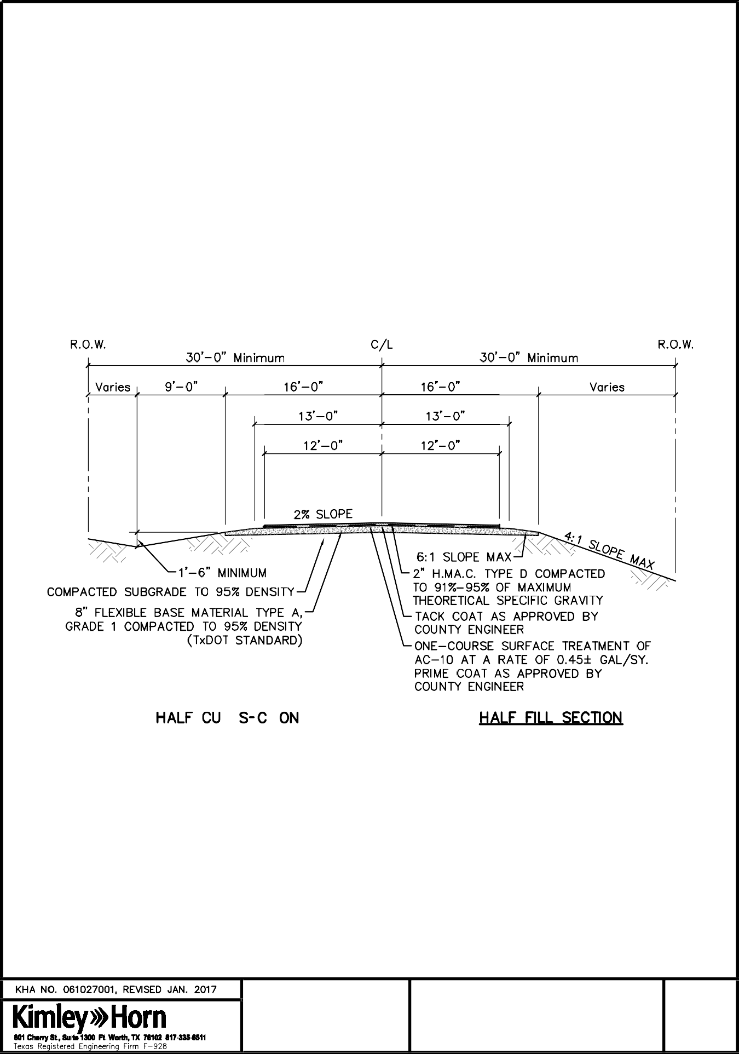

TYPICAL ROADWAY SECTION BORROW DITCHES
1

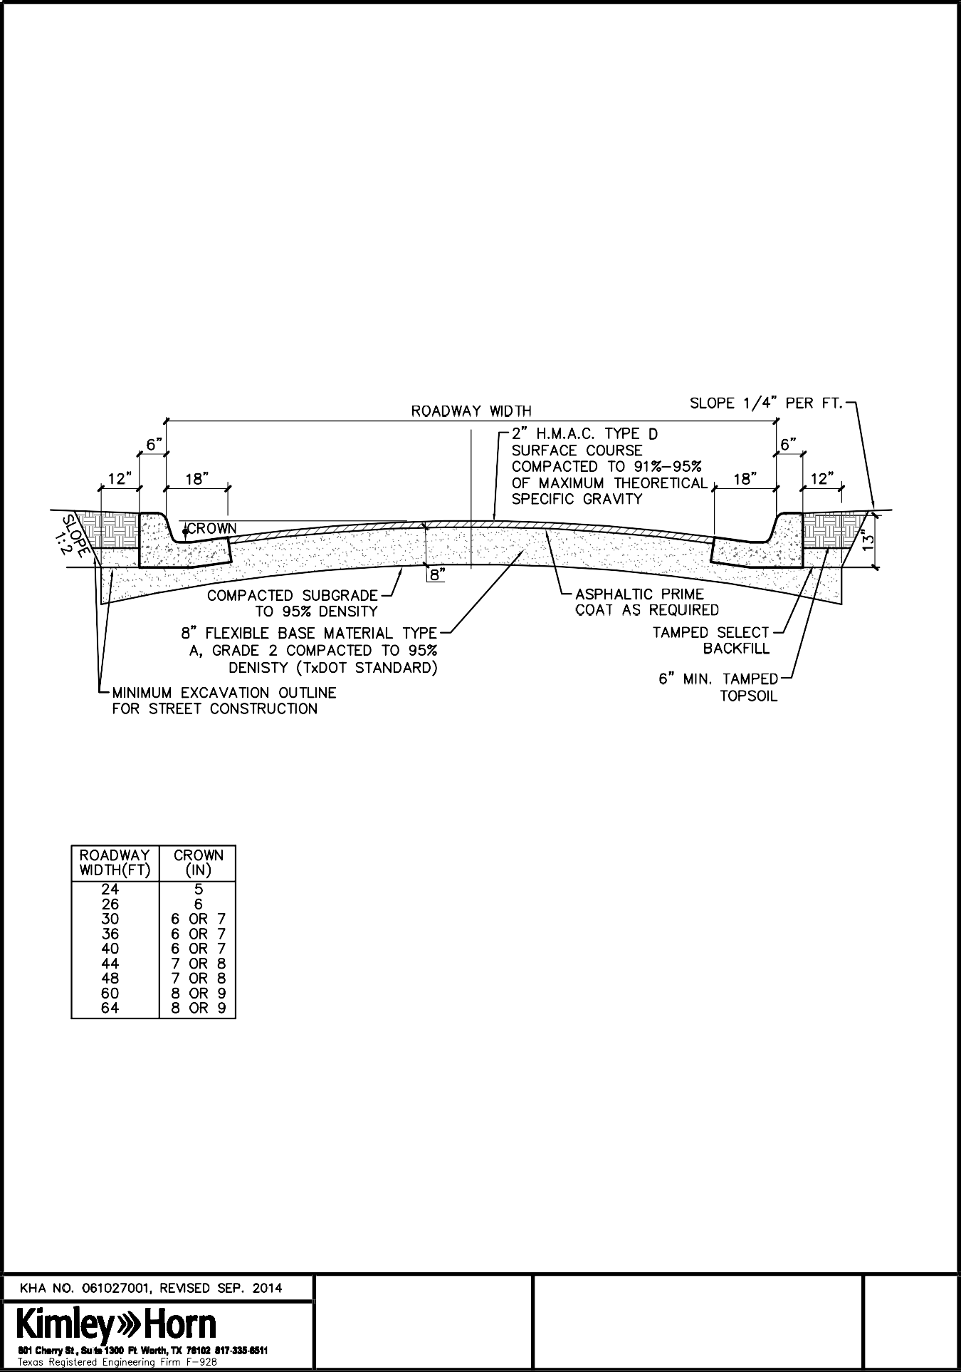

TYPICAL ROADWAY SECTION
2

CURB AND GUTTER

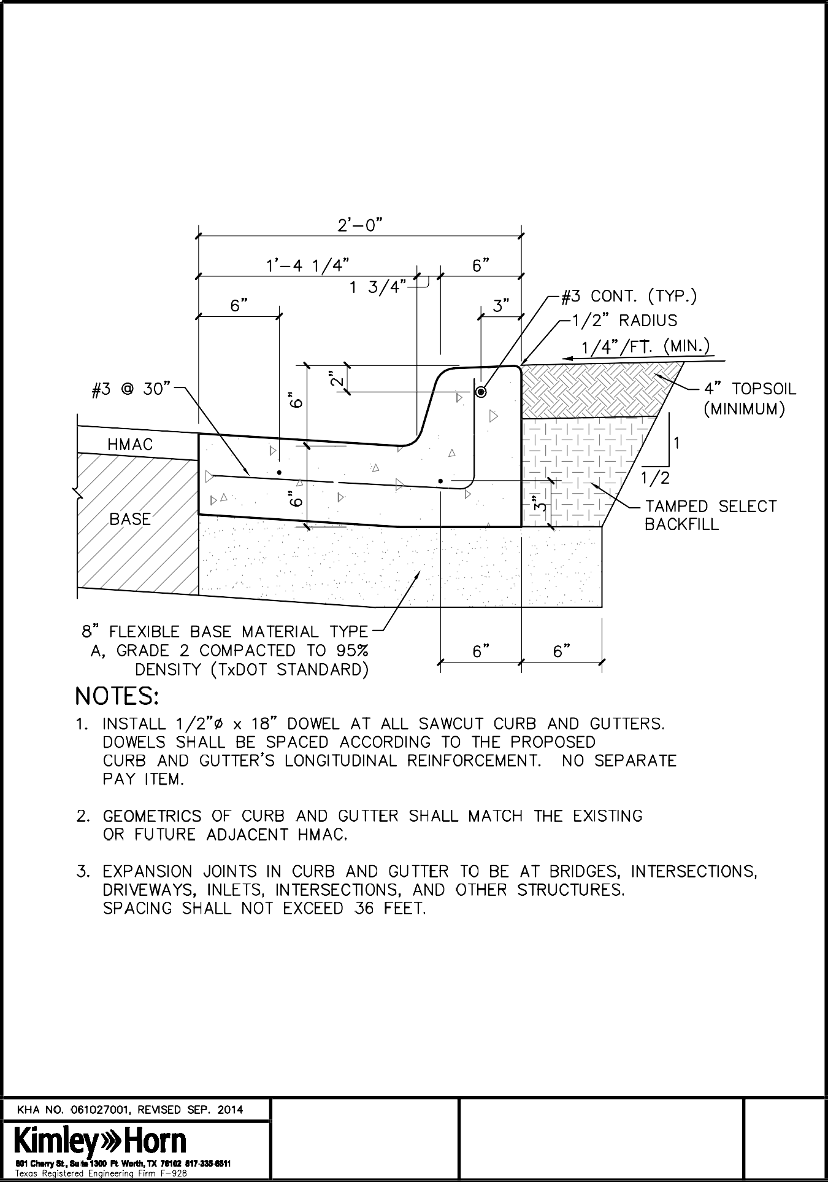

TYPICAL CURB SECTION STANDARD 6" CURB
3

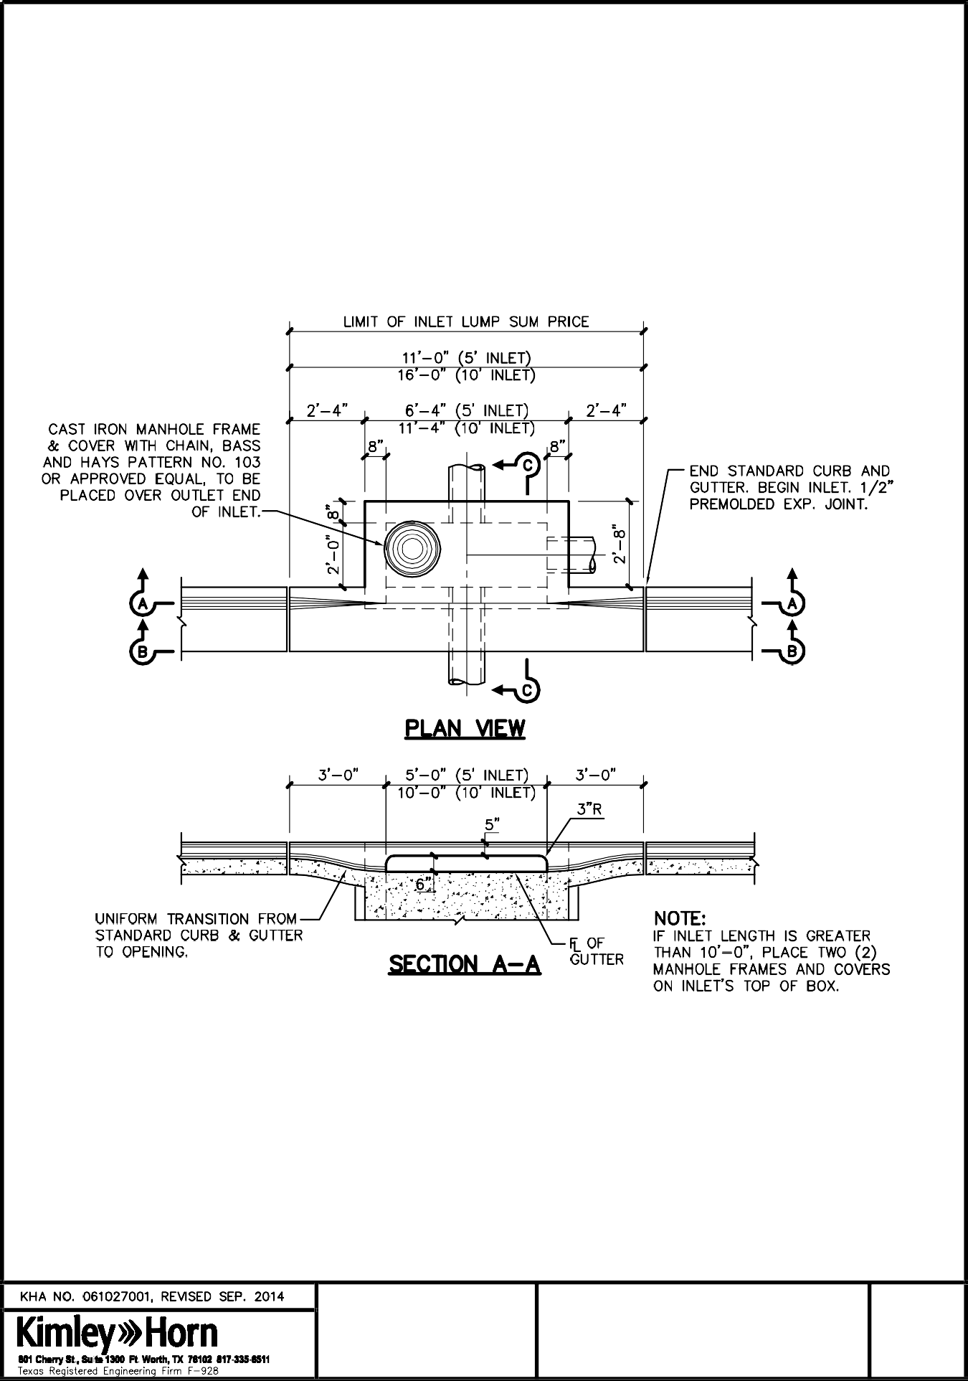

STANDARD STORM DRAIN CURB INLET DETAIL
4A

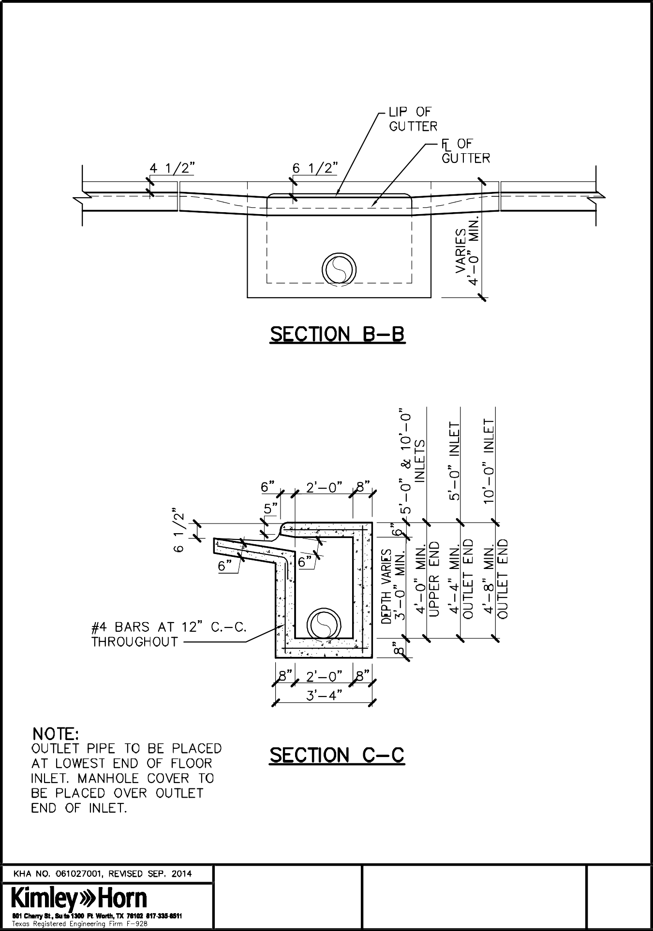

STANDARD STORM DRAIN CURB INLET DETAIL
4B

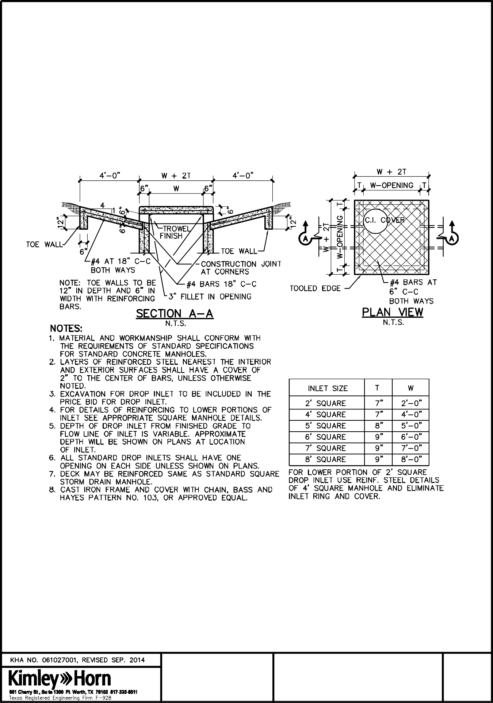

STANDARD STORM DRAIN DROP INLET DETAIL
5

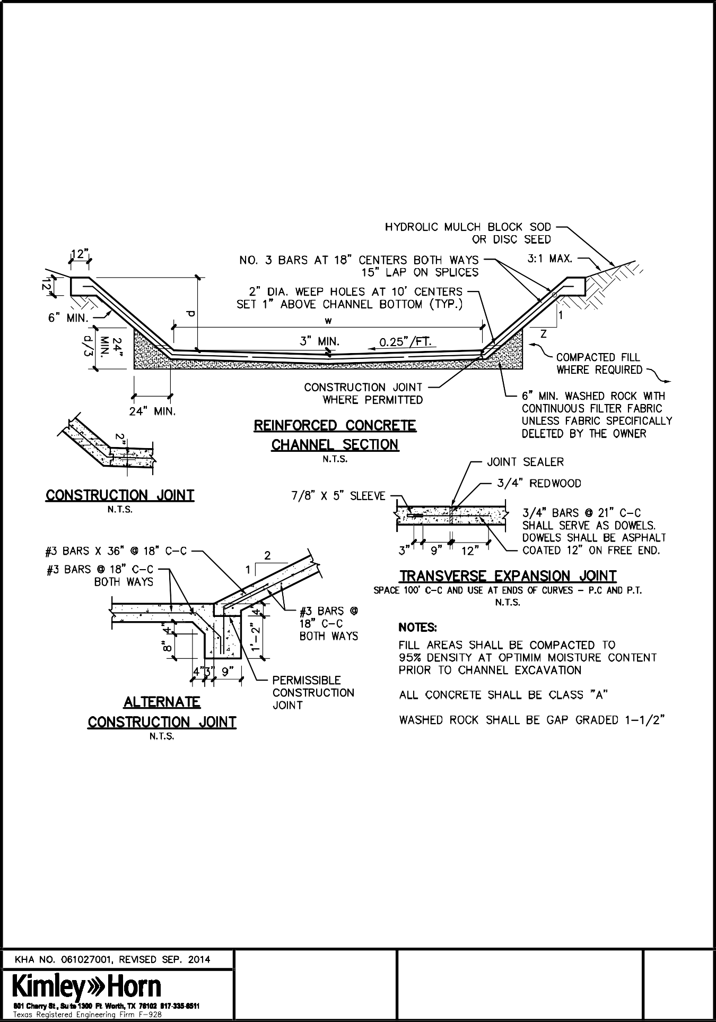

FULL CHANNEL LINING CONCRETE REINFORCED
6

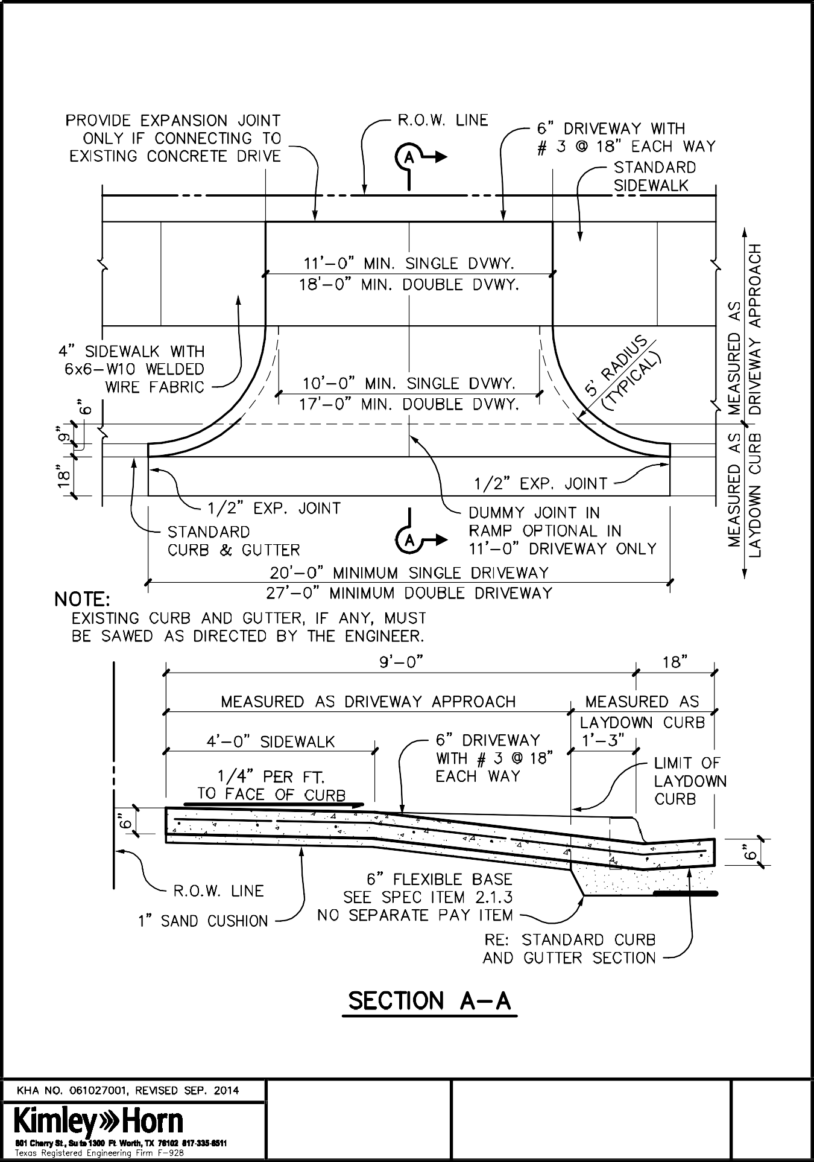

LAYDOWN CURB AND DRIVEWAY
7

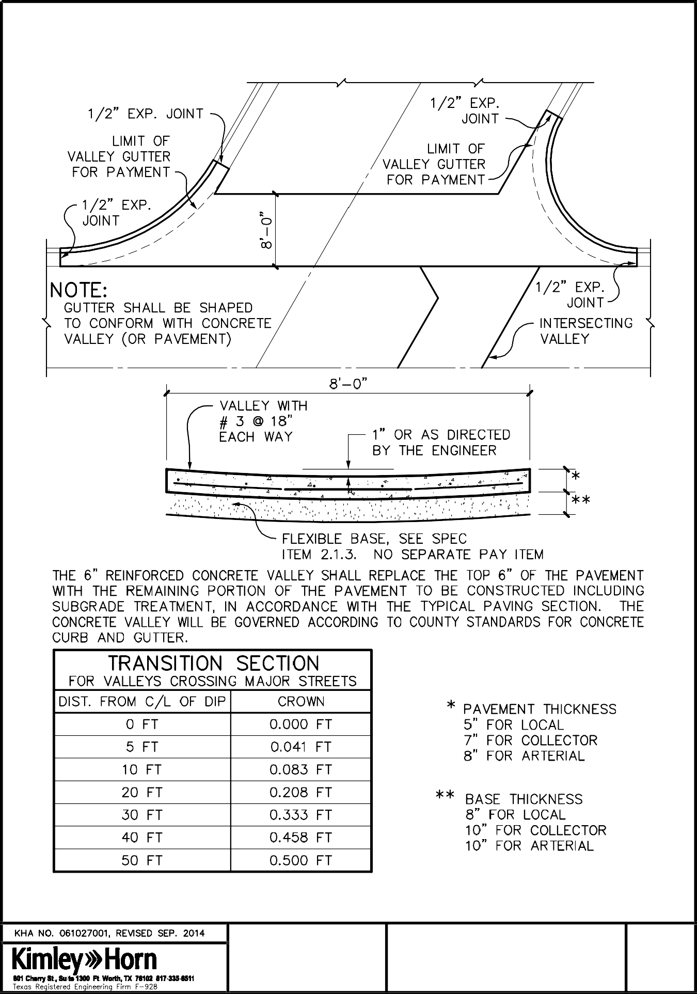

CONCRETE VALLEY GUTTER
8

TYPICAL SECTION

CONSTRUCTION OF
(SUBDIVISION NAME) PHASE (X)
OF YOUNG COUNTY, TEXAS HAS BEEN APPROVED BY
THE COMMISSIONER'S COURT (DATE)

Hon. (COUNTY JUDGE) (NAME)
(COMMISSIONER), Precinct (X) Developer
516 FOURTH ST. (STREET ADDRESS)
GRAHAM, TEXAS 76450 (CITY, STATE, ZIP)
940-549-2030 (TELEPHONE)
 |  | CONSTRUCTION SIGN STANDARD DETAIL | 9

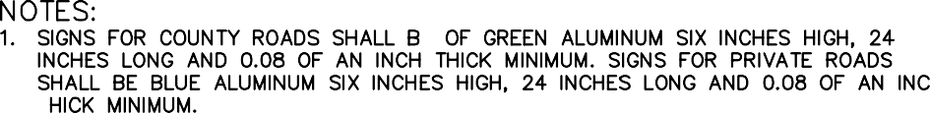

ROAD SIGN STANDARD DETAIL
10

APPENDIX

Young County, Texas - Trip Generation Threshold Analysis Worksheet

Submittal Date:

Development Name:

Approximate Location:

Proposed Land Use and Trip Generation Data for Buildout of Development
Land Use Type | Intensity | Units | ITE Code | Equation Used (i.e. Rates or Regression) | Daily Total (Weekday) | AM Peak Hour |  |  | PM Peak Hour |  |  | Sat Peak Hour
 |  |  |  |  |  | In | Out | Total | In | Out | Total | In | Out | Total
 |  |  |  | TOTALS:

November 2008 Threshold Analysis Worksheet

Trips shall be calculated using the most recent version of the ITE Trip Generation Manual

Notes: seal / signature / date

- A Traffic Impact Analysis (TIA) will be required when the development is expected to generate 1,000 of more vehicle trips per day, add 100 or more parking spaces, OR 100 or more vehicle trips in the peak direction (i.e. inbound or outbound) during the site's peak traffic hour.
- The Precinct Commissioner may require a TIA at any stage of a development whether it meets this criteria or not if special circumstances exist that may require a TIA.
- If a TIA is needed based on this Threshold Worksheet, the developer shall contact the Precinct Commissioner to determine the actual study requirements regarding time periods, study area intersections, etc.
- The use of internal capture trip reduction rates shall not be permitted without the prior approval of the Precinct Commissioner.
Threshold Worksheet Completed By:

Name: Address:

Phone:
Trip Generation Threshold Analysis Worksheet shall be completed by a Licensed Professional Engineer in the State of Texas with experience in Transportation Engineering

Subdivision and Development Rules and Regulations
Young County, Texas
85
April 2021
THIS SECTION FOR COUNTY USE ONLY: Based on this submittal, a TIA is hereby REQUIRED or WAIVED (circle one)
Name: Title: Date:

Young County Subdivision Checklist
For developments with 3 lots or fewer where no portion of the subdivision lies within floodplain and no public or private roadway improvements are planned to be constructed. Replats should follow the Final Plat form and content.

Final Plat Package Items

Receipt for Final Plat filing fee
5 copies (1 being reproducible) of Final Plat 3 copies of Drainage Plan
Sewage Disposal Plan (if On-Site Sewage Facilities are to be used) Current Tax Certificates
Letter of Approval (if affected) for provision of service from:
Water Electric Natural Gas Telephone TxDOT
Soil and Water Conservation District
School District (for subdivisions with 25 lots or greater)
Any holder of dedicated easements or right-of-way within or immediately adjacent to subdivision
County approval of street names and street address numbering for all houses from the County 911 Service Administrator
Subdivision Restrictions

Young County Subdivision Checklist
For developments with more than 3 lots and/or public or private roadway improvements.

Preliminary Plat Package Items

Receipt for Preliminary Plat filing fee 3 copies of Preliminary Plat Preliminary Drainage Plan
Sewage Disposal Plan (if On-Site Sewage Facilities are to be used) Traffic Threshold Analysis/TIA (for subdivisions greater than 100 lots) Developer’s Statement which includes:
Results of research that ensures adequate water supply (TAC Chapter 230 form for groundwater sources) Letter of agreement from water purveyor (if applicable) Description of waste collection and disposal system
Plan for providing electric, telephone and other utility service Restrictions that will affect any lot within the subdivision

Final Plat Package Items

Receipt for Final Plat filing fee
5 copies (1 being reproducible) of Final Plat
3 copies of Construction Plans including Drainage Plan Current Tax Certificates
Letters of Correspondence (if affected) for provision of service from:
Water Electric Natural Gas Telephone TxDOT
Soil and Water Conservation District
School District (for subdivisions with 25 lots or greater)
Any holder of dedicated easements or right-of-way within or immediately adjacent to subdivision
County approval of street names and street address numbering for all houses from the County 911 Service Administrator

Young County Subdivision Application – Preliminary Plat
This Subdivision Application must be filled out and submitted along with all items required (as listed below) to be formally considered for review by Young County. No application will be reviewed without all required items.
Subdivision Name: Precinct No. Subdivision Location: Project Contact Person: Telephone No. Mailing Address: Fax No.
Email: Requesting: Preliminary Plat Review
Preliminary Plat Review Items: (please check)
(Send to Young County Development Services for review)

Receipt for Preliminary Plat review fee 2 copies of Preliminary Plat Preliminary Drainage Plan
Sewage Disposal Plan (if On-Site Sewage Facilities are to be used)
Traffic Threshold Analysis/TIA (for subdivisions greater than 100 lots, institutions, any non-residential or multi-family developments)
Developer’s Statement which includes:
Results of research that ensures adequate water supply (TAC Chapter 230 form for groundwater sources) Letter of agreement from water purveyor (if applicable) Description of waste collection and disposal system
Plan for providing electric, telephone and other utility service Restrictions that will affect any lot within the subdivision

Preliminary Plat Items for consideration at Commissioner’s Court:
(Upon receipt of final review letter from Young County Development Services and Owner contacting Judge’s office to have subdivision placed on Commissioner’s Court Agenda, bring to Commissioner’s Court the following)

3 copies of Preliminary Plat Preliminary Drainage Plan
Sewage Disposal Plan (if On-Site Sewage Facilities are to be used)
Traffic Threshold Analysis/TIA (for subdivisions greater than 100 lots, institutions, any non-residential or multi-family developments)
Developer’s Statement

Young County Subdivision Application – Final Plat and Replat
This Subdivision Application must be filled out and submitted along with all items required (as listed below) to be formally considered for review by Young County. No application will be reviewed without all required items.
Subdivision Name: Precinct No. Subdivision Location: Project Contact Person: Telephone No. Mailing Address: Fax No.
Email: Requesting (check one): Final Plat/Construction Plan Review Replat Review
Final Plat or Replat Review Items: (please check)
Send to Young County Development Services for review.

Receipt for Final Plat review fee 2 copies of Final Plat
1 set of Construction Plans including Drainage Plan Current Tax Certificates from:
Letters of Correspondence (if affected) for provision of service from: Water
Electric Natural Gas Telephone TxDOT
Soil and Water Conservation District
School District (for subdivisions with 25 lots or greater)
Any holder of dedicated easements or right-of-way within or immediately adjacent to subdivision

County approval of street names and street address numbering for all houses from the County 911 Service Administrator Subdivision Restrictions and Deed Restrictions

Final Plat or Replat Package Items for Commissioner’s Court:
Upon receipt of final review letter from Young County Consulting Engineer and confirmation by the Owner that the development has been placed on the Commissioner’s Court Agenda, bring to Commissioner’s Court the following.
6 copies of Final Plat (signed and notarized) 2 Mylar copies
4 copies

3 sets of Construction Plans including Drainage Plan Current Tax Certificates
County approval of street names and street address numbering for all houses from the County 911 Service Administrator Letters of Approval (if affected) for provision of service
Subdivision Restrictions and Deed Restrictions

PERMIT TO CONSTRUCT ACCESS DRIVEWAY FACILITIES ON YOUNG COUNTY RIGHT-OF-WAY

Name/Applicant: Date: Address: Phone #:

Young County Precinct # , hereinafter called the County, hereby authorizes
, The owner of an interest in the land to incur the benefit, hereinafter called Applicant, to (re)construct an access driveway on the County right-of-way abutting County Road Name , in Young County, Texas located at
. This permit is issued solely as part of the County’s authority to manage and control use of and matters of public safety, maintenance and construction on County public roads and is based on the Applicant’s sworn assertion of a private right of access to said property and is not a determination of whether the Applicant’s assertions are correct or truthful. In the event the Applicant does not have a legal right of access to the property, the County may revoke this permit and cause any construction made on the right of way under authority of this permit to be removed, and may request an investigation to determine whether criminal charges should be filed.
SUBJECT TO THE FOLLOWING:

- An approval letter from the County 911 Service Administrator for street address numbering is required.
- The Applicant is responsible for all costs and liabilities associated with the construction of this access driveway and culvert subject to approval by the County.

- The driveway angle from the county road shall be between 75 to 90 degrees. The design and construction are subject to the approval and inspection of the County. If the facilities do not meet the County’s requirements, they will be removed or repaired at the Applicant’s expense
- The Applicant shall cause a culvert to be installed as approved by the County. The County will determine the diameter of the CMP or RCP pipe with a TxDOT approved Safety End Treatment required for culverts 24” and larger. For culverts less than 24”, Safety End Treatments will be required at the discretion of the County Commissioner. The slope for Safety End Treatments shall not exceed four (4) feet horizontal to one
  - foot vertical. The pipe will be covered with a suitable fill material approved by the County.

- The County’s agent for supervision and approval of the construction shall be the County Road Commissioner (and his designee) having jurisdiction of the road on which the construction is to be made.
- Maintenance of the driveway facilities constructed hereunder shall be the responsibility of the Applicant, and the County reserves the right to require Applicant to make any changes and repairs or to perform maintenance of the improvement deemed appropriate by the County for the welfare of the public and consistent with the use of the roadway as a public right-of-way. In the event that the Applicant fails to make the required changes, repairs, or to perform maintenance after notice from the County or after the County has made a reasonable effort to give notice, or in the event public safety reasonably necessitates immediate repairs without the delay of notice, the County may make changes, repairs, or perform maintenance at the expense of the Applicant. The granting of this permit does not grant or convey any private right or private interest in the right-of-way of the road on which the construction is done. The County retains all ownership and management rights in said right-of-way. No alteration of the driveway facility, as approved by the County, shall be made without the express written permission of the County.
- The Applicant shall hold harmless the County and it’s duly appointed agents and employees against any action for personal injury or property damage sustained by reason of the exercise of this Permit.

- This Permit will become null and void if the above-referenced driveway facilities are not constructed within six (6) months from the issuance date of this Permit.
- The Applicant will contact the Young County Precinct # Representative at least twenty-four (24) hours prior to coverage of pipe authorized by this Permit.

- It is the responsibility of the Applicant and/or Installer to contact the “1-800-DIG TESS” number and arrange for the marking of underground lines prior to any excavation or any installation.
- The County will enforce strict compliance with the requirements set forth in this permit.

- Mailboxes along County Roads shall be placed with a minimum lateral distance of eight (8) feet from edge of driving surface. Mailbox placement and construction shall be in accordance with the most recent edition of AASHTO, Roadside Design Guide

The Applicant hereby agrees to comply with the terms and conditions set forth in this Permit for construction of an access driveway on the County right-of-way.
Dated this day of , 20 .
By

